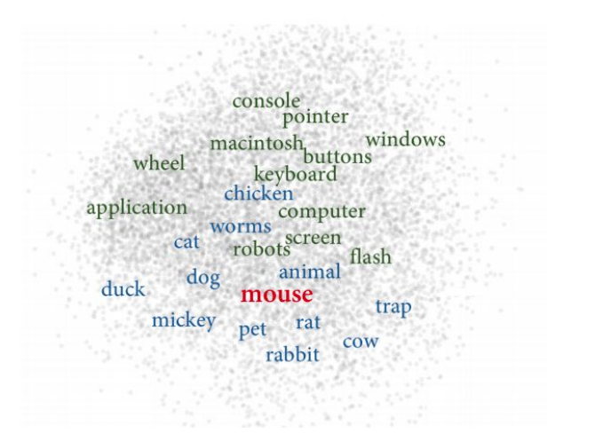
Recap

The problem was that a word like mouse have two different meanings related to two different fields

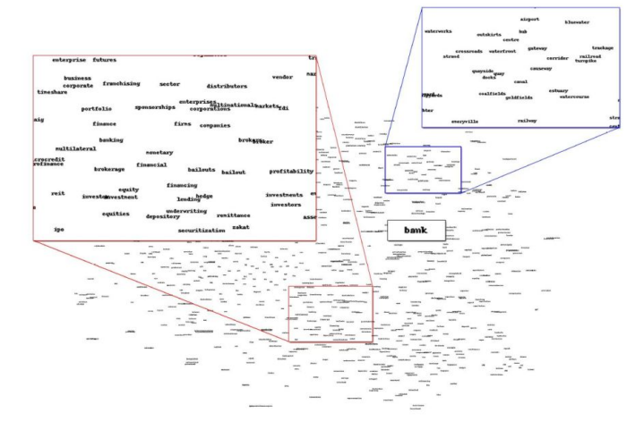
We have a problem of meaning conflation deficiency, so far a word could be seen as a mapping as a single vector but a word can have multiple meanings and so we can not capture polysemy.

The word bank was located between two different senses (bank for money and bank of a river). This is a problem because it is in the middle while it should be close to both the different fields of the word bank. Furthermore if it is in the middle it might even be close to unrelated words of another field.

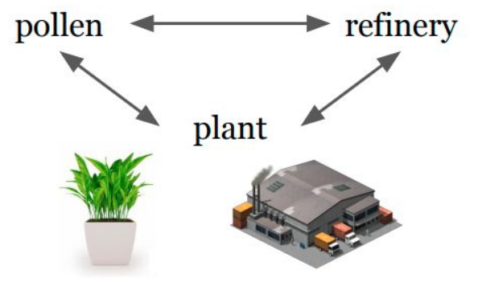 ⟹ 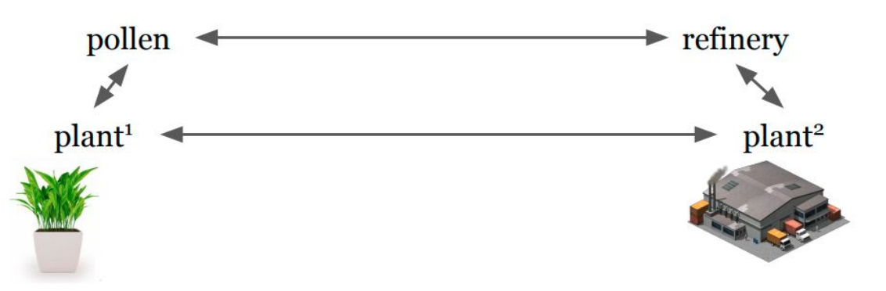

Plan can be an ambiguous word, ideally we would like to have two different representations (plant¹ and plant²) where one is related to the word pollen and another vector representation for the other meaning of plan that is closer to the topic of refinery.

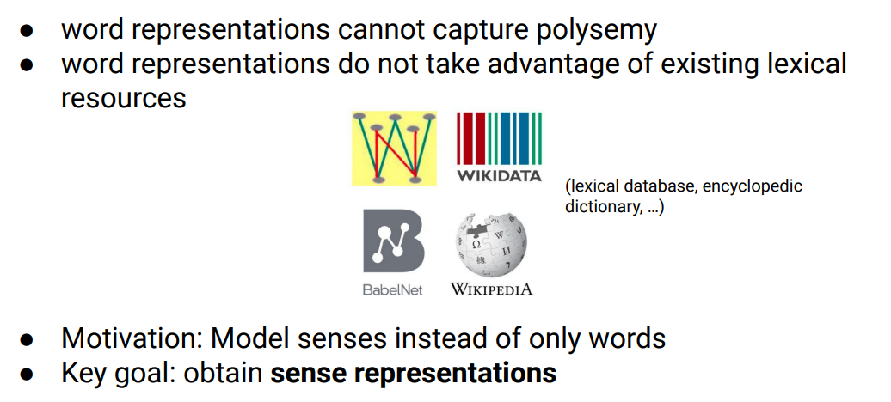
We have some lexical resources that so far we did not exploit and they are a sort of dictionary where for each word the dictionary lists the senses of a word and it give definition about the senses and examples and provides relations between words.

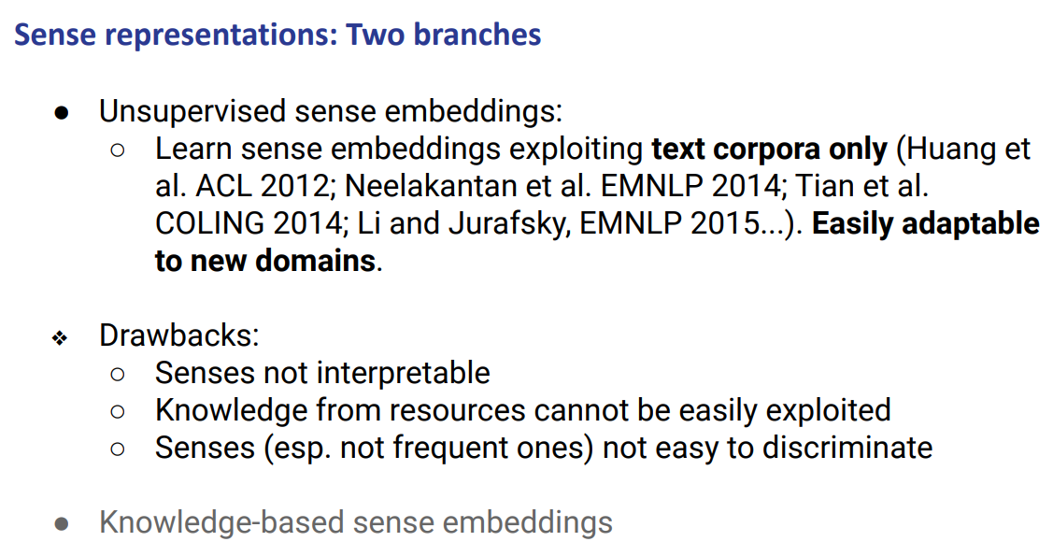

Usually in order to obtain word representation we have two branches
- Unsupervised sense embedding 🙁 : it basically learns sense embedding by exploiting text corpora only. They try to learn senses from row corpus. It tries to differentiate for each word different senses. Usually they are not interpretable because they are not really linked to any dictionary, provide different senses but can not understand to which is related. Also they do not exploit any resources.

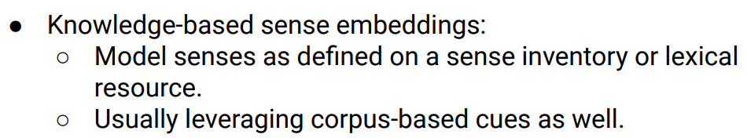
- Knowledge-based sense embeddings 🙂: they use dictionary (so we do have lexical information) and we can use to learn sense representation and we can see the representation for each sense (because is linked to a dictionary, so it is intepretable)

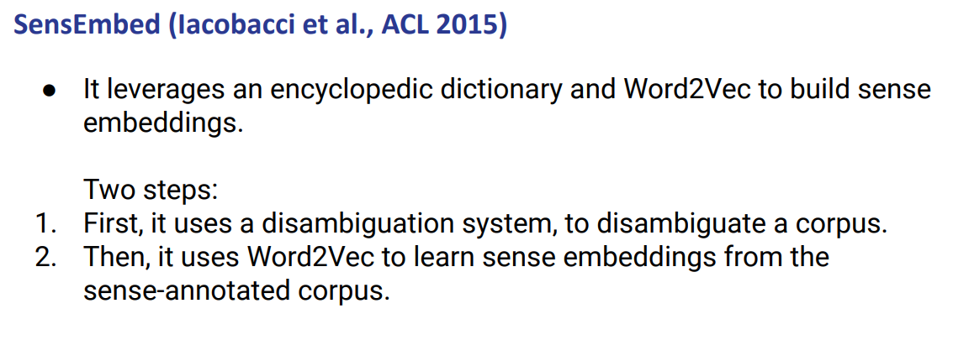
It uses a word sense disambiguation system. It disambiguates a corpus.
- First use disambiguation system
- Then use Word2Vec to actually learn word and sense representation

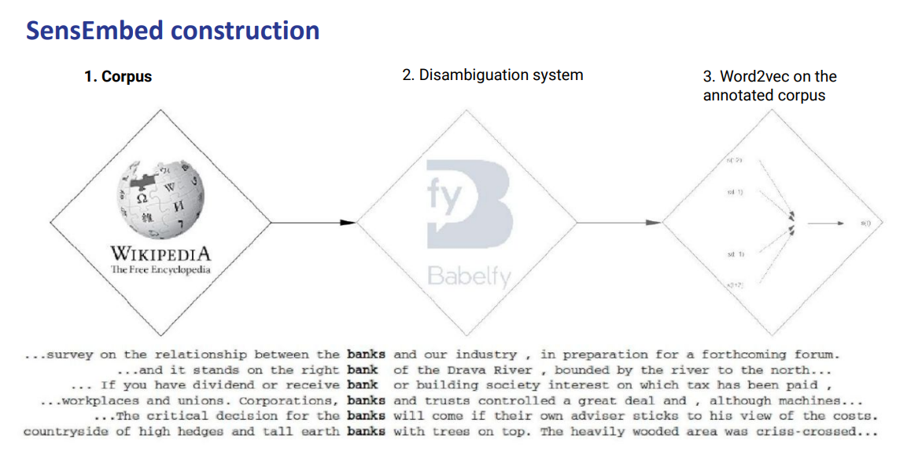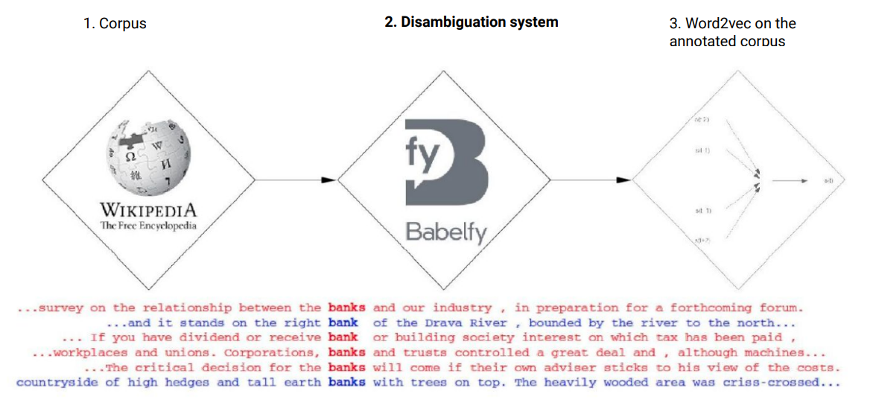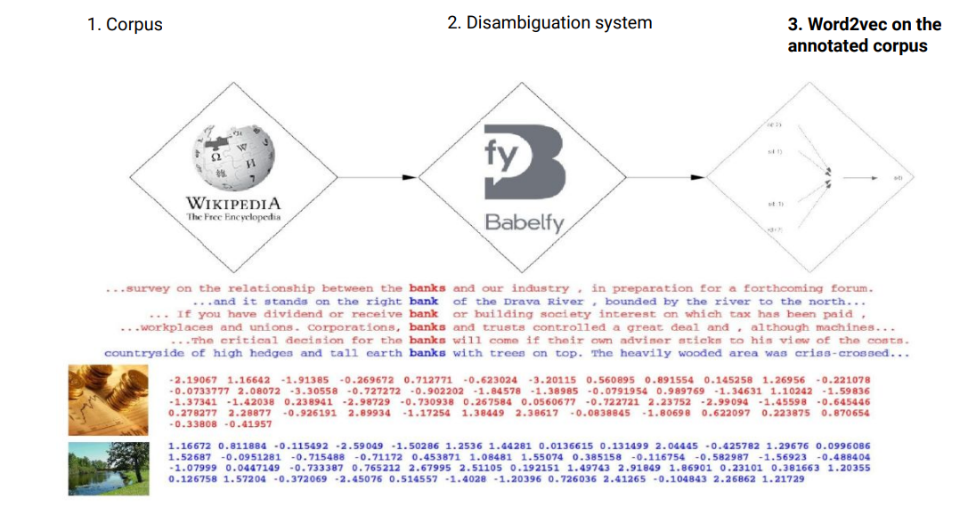

As an example it takes Wikipedia corpus (a bunch of sentences that focus on the word bank)

They use a off-the-shelf system (link Babelfy) that takes a word and links it to a dictionary. Basically you rely on the accuracy of the system but if the system is good enough then the error that the system could do will not impact the representation so much (anyway better system ⟹ better it is)

Then you learn Word2Vect on top of that. When you train word2Vect with two different representations of the word bank.

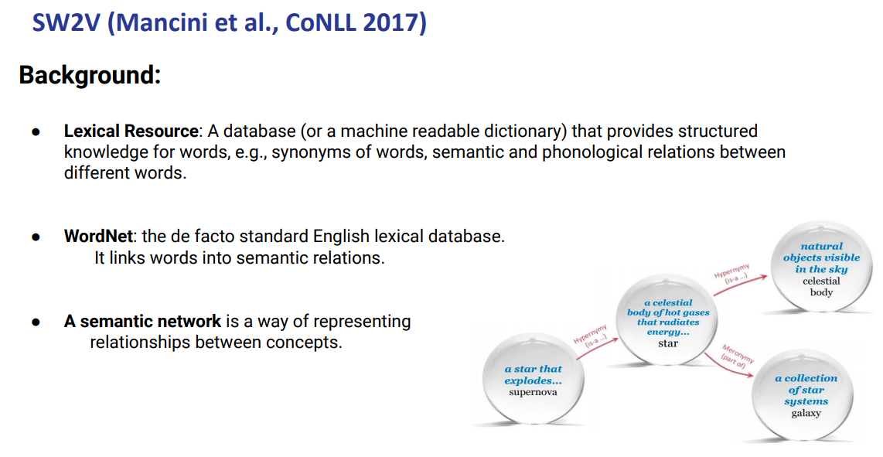

SW2V (sense word to vect)

It is similar to SensEmbed, but there is a way to choose a sense. It uses its own disambiguation system.

It needs lexical resources, we need to link a word to a particular sense, it is a sort of semantic network: it does not provide only for each word a list of senses (with its own definitions and usages), but also provides the relation between all the senses. We have a relation with all the senses in the dictionary.

We can exploit this relation to build the disambiguation system

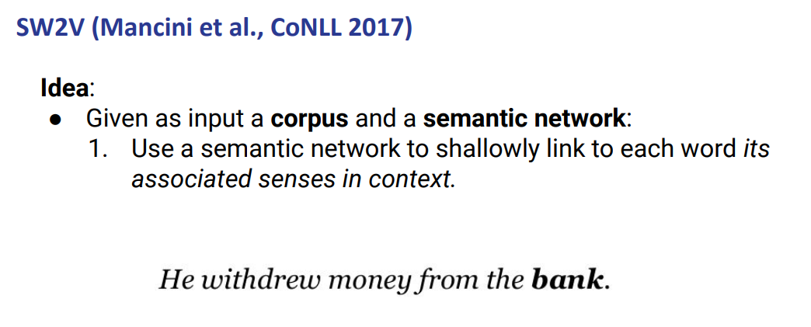

Given as an input a corpus and a semantic network (the dictionary) we use the shallow link each word to the associated sense

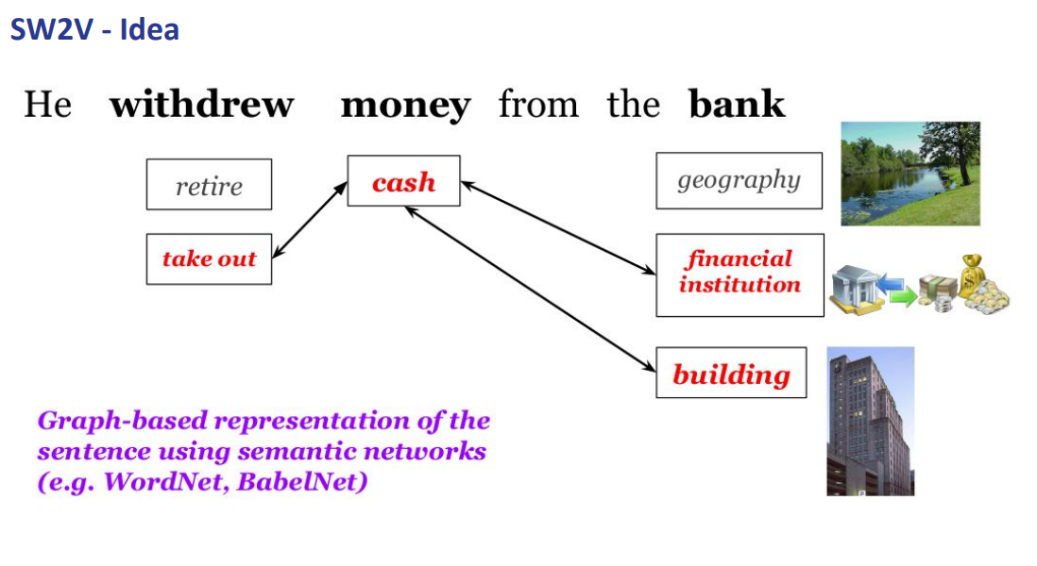
withdrew has two possible senses, money has one sense and bank has three possible senses. Theses senses are provided by the dictionary

To be more precise the dictionary (the semantic network) actually provides relations between senses. And if we look at the relation we can see that the relations connect different senses.

We exploit the connection and if for example bank is linked to two or more senses we will use both senses (because probably there is a silty difference between the two and both of them are fine)

You can have cases with more connections and you need a cutoff to see which one are more connect and decide.

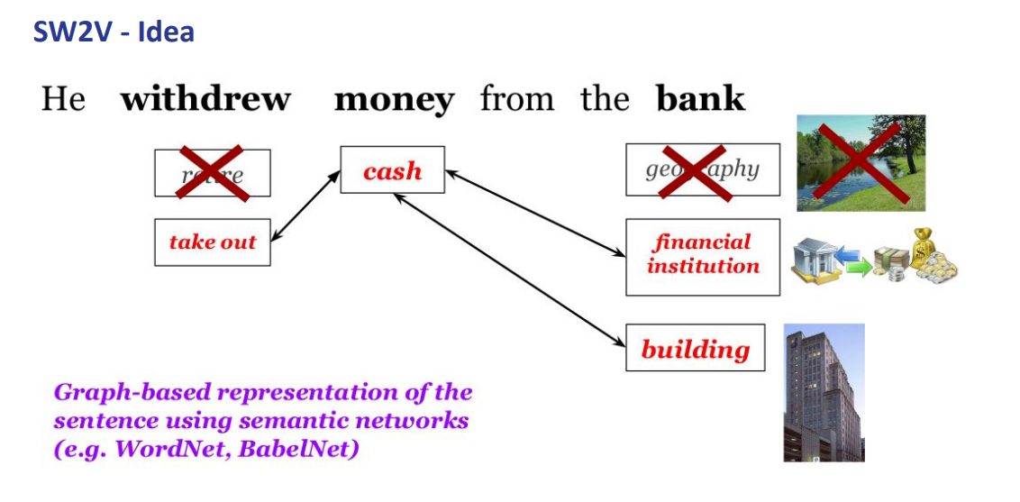

But the idea is that you use the relation between the senses and choose those that are connected to each other.

so we remove the senses that are not connected.

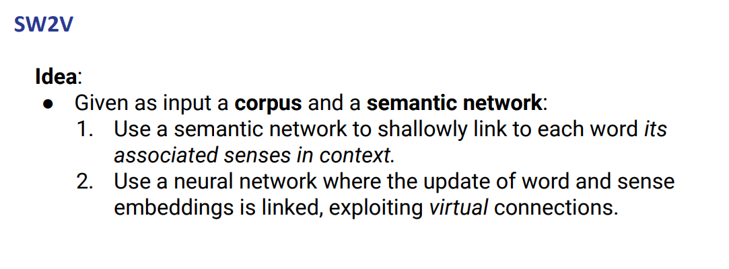

Then we can train a word2vec model on top

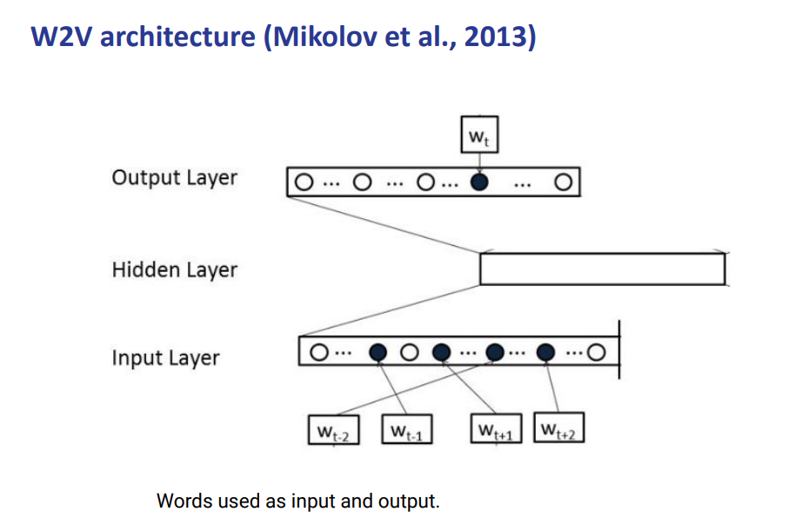
It is CBOW (you predict the target word from a context)

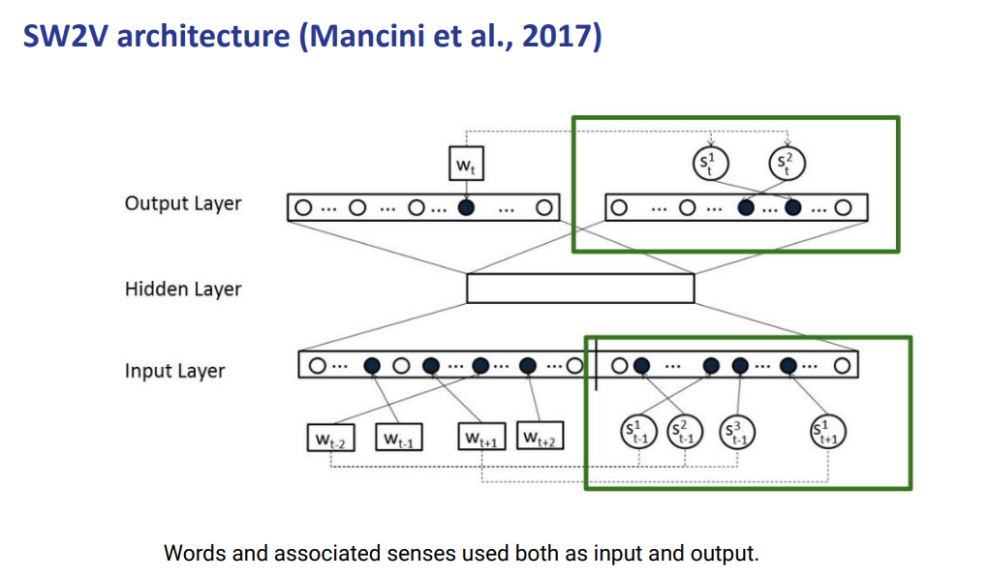

We add as input layers all the senses that appear in the input sense. You will get all the senses as input.

You output the actual sense (takeout, cash, financial institution, building)

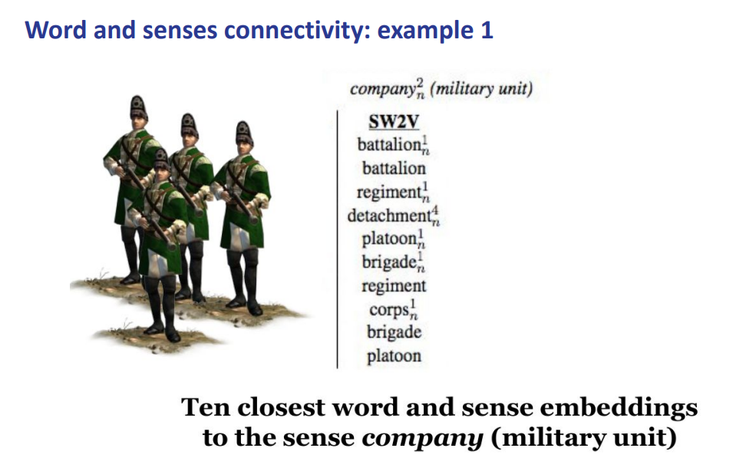
With the cosine similarity you can inspect if they learn something meaningful. This system provides good representation

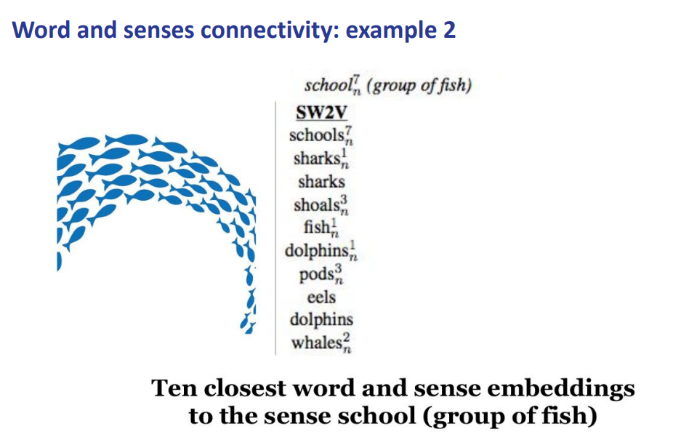group of fish senses.

Embedding learning algorithms
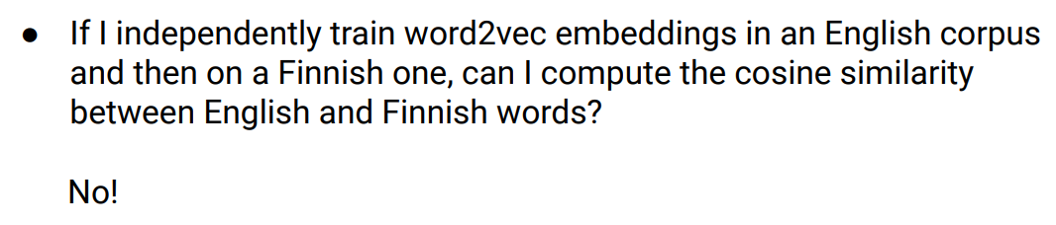

I try word2vec in English corpus and then with Finnish one, can I compute cosine similarity between English and Finnish words?.

You mathematically can compute it but it has no meaning to do this comparison because they live in two different vector spaces.

There is no meaning to do operation once you train a system to do one language then it lives in its own space and the other language is in a different space. You can do it but the number you get as output has no meaning.

Once you train a system to do one thing (in this case is word embedding) they it lives in its own space and if you retrain again it lives in its own space.
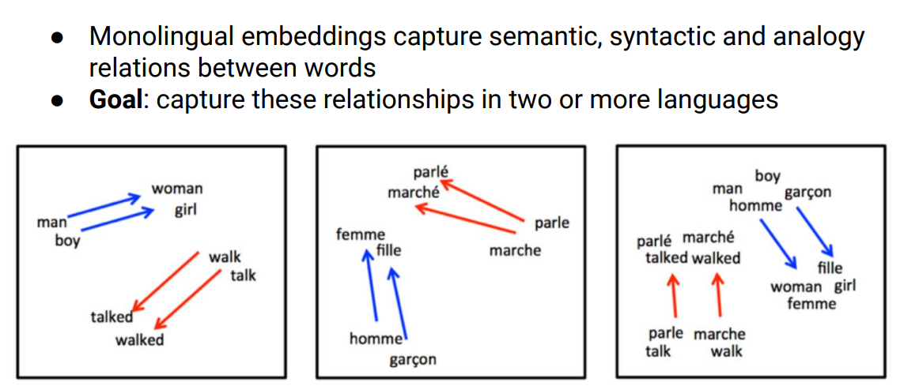
we would like to have something that can link the words with translation close to each other to actually compute similarly between words. We want to compute the relationship between two or more languages.

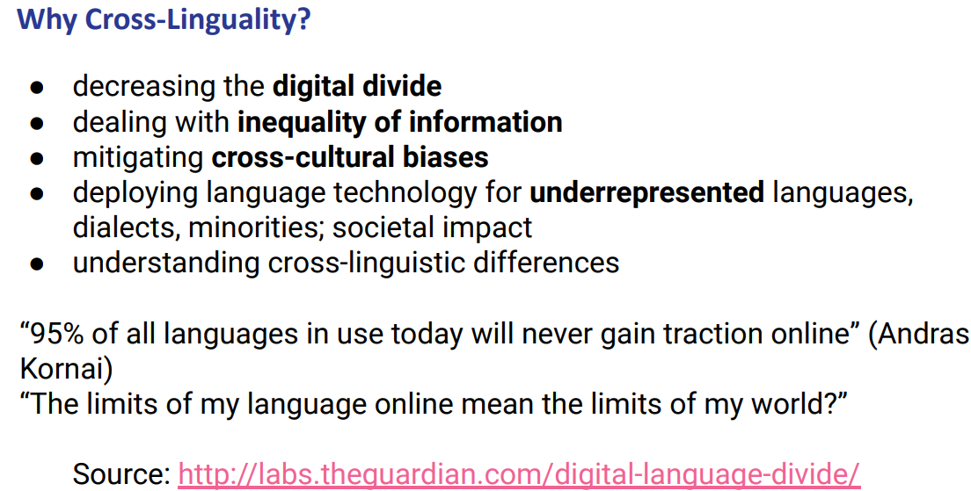
That is not really how it works. the usage of language it is an impact, you have different amount of data for each language, maybe you will prefer to use a system just for one language (you can have more data or it is simpler)

we need to have mechanism to incorporate many languages

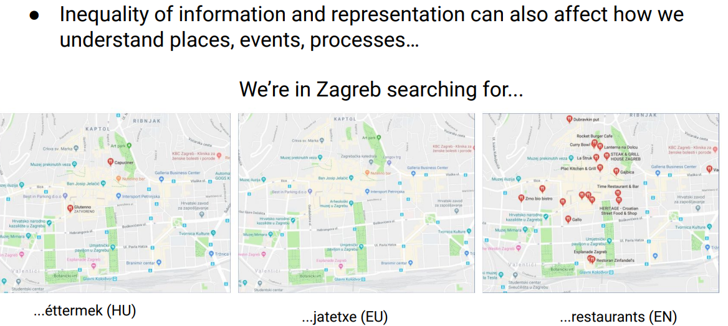

We care to have something to know that two words in English have different sense.

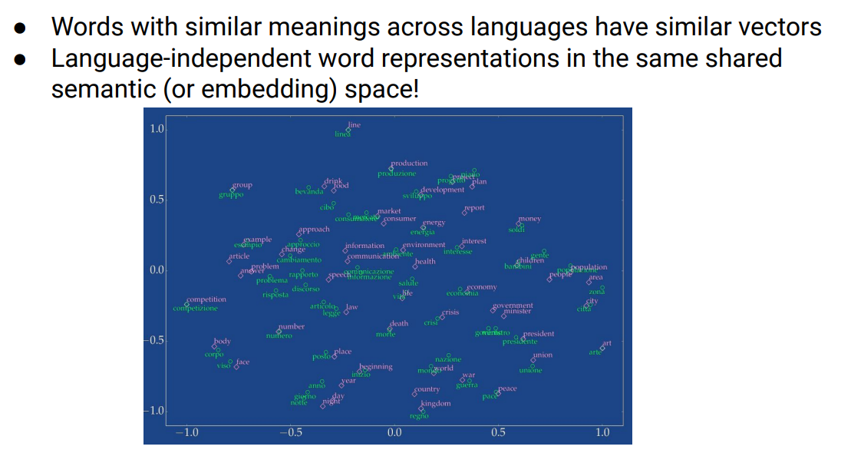

We want words similar in two languages that have similar meaning. regno and kingdom should be similar (high cosine similarity)

We want to have words similar in 2 languages to be closer

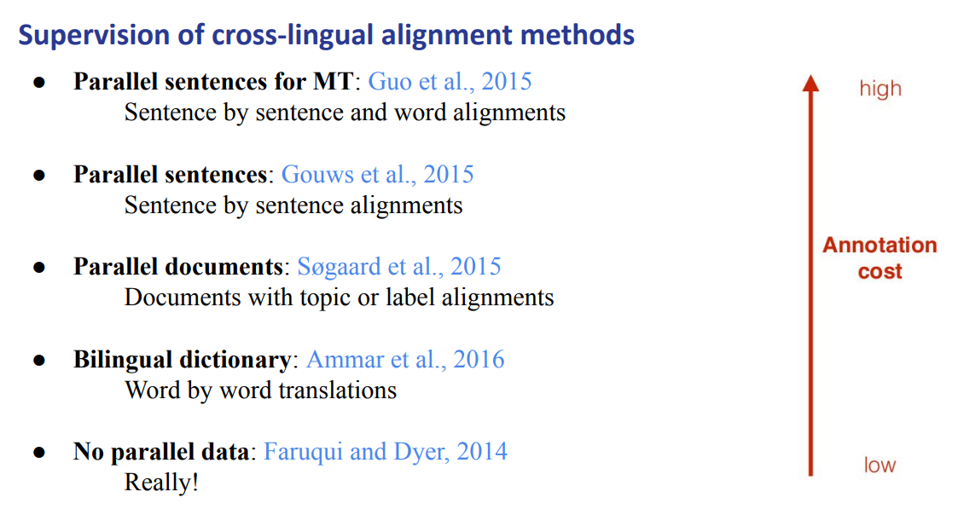
different multilingual representation. There are different ways to learn, depends on data. We can do it with even no parallel data our use bilingual dictionary

Different ways to learn the cross lingual methods. Depends on the amount of data that you have. You can do it without no parallel data (without translation).

You can also use a bilingual dictionary (tells you the connections between other languages)

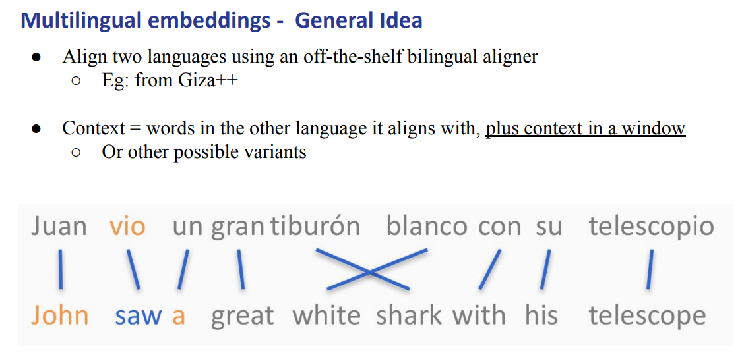
The words are linked together. Make a word aliment we can take a context

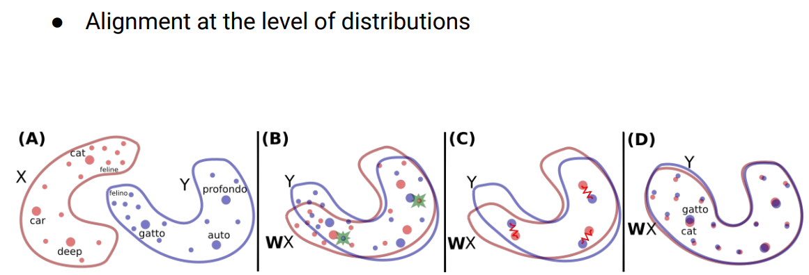

different vector space and we can not compute the similarity across the two. If we train on the english wikipedia and then on the italian one the distribution more or less will be similar.

most probability what you will get two similar shapes of the two word embeddings.

We want a mechanism to let the two similar word embedding communicate. We want a way to compute the similarity, a way to do it is to play with the representation and we can align two different distributions.

You need to find a matching of the two representations

You train the two word embedding independently. You try to find a rotation mapping until gatto and cat are closer to each other. You just need few words

Then you try to find a rotation mapping that moves everything closer until gatto and cat are close to each other. Once you find you can compute similarity between the two word embedding

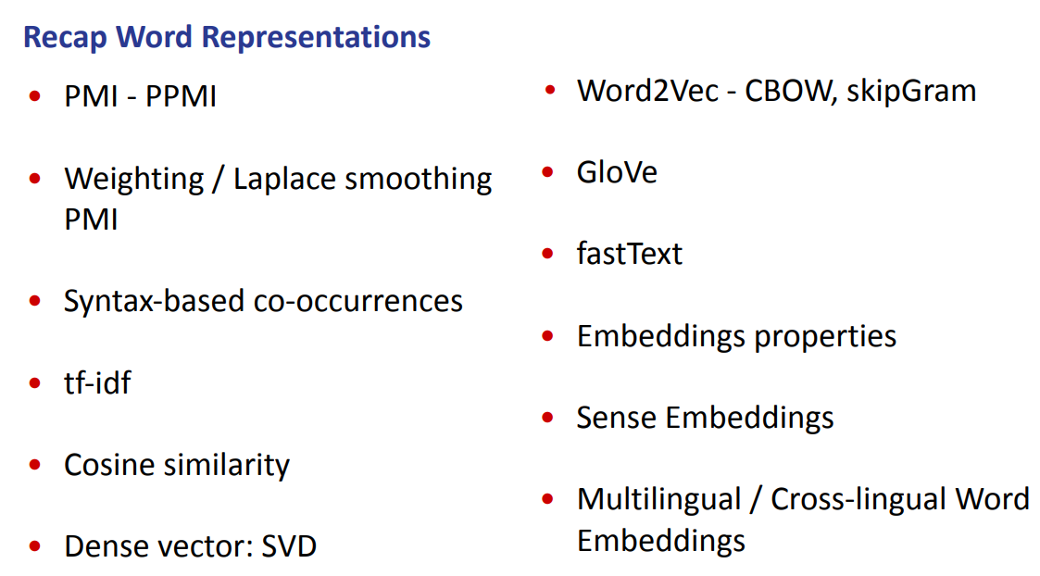
We say that we can syntax to do the counting of co-occurrences in order to get better context.

tf-idf: to compute document similarity
cosine similarity: compute similarity across words in the vector space
Dense vector: SVD

Word2Vec, CBOW and skipGram

Glove: based more on the statistic of the corpus
FastText: try to overcome the limitation of out of vocabulary words

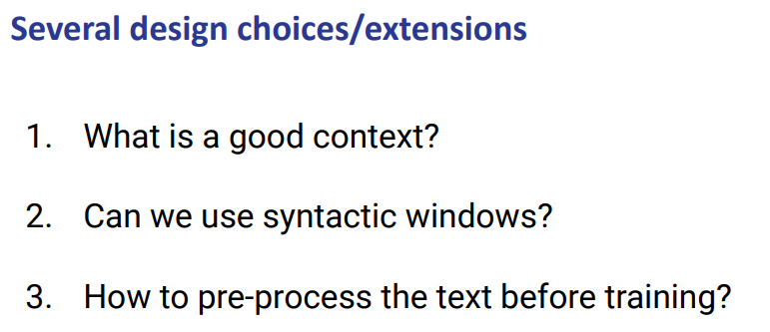
for all these method there are several design choices

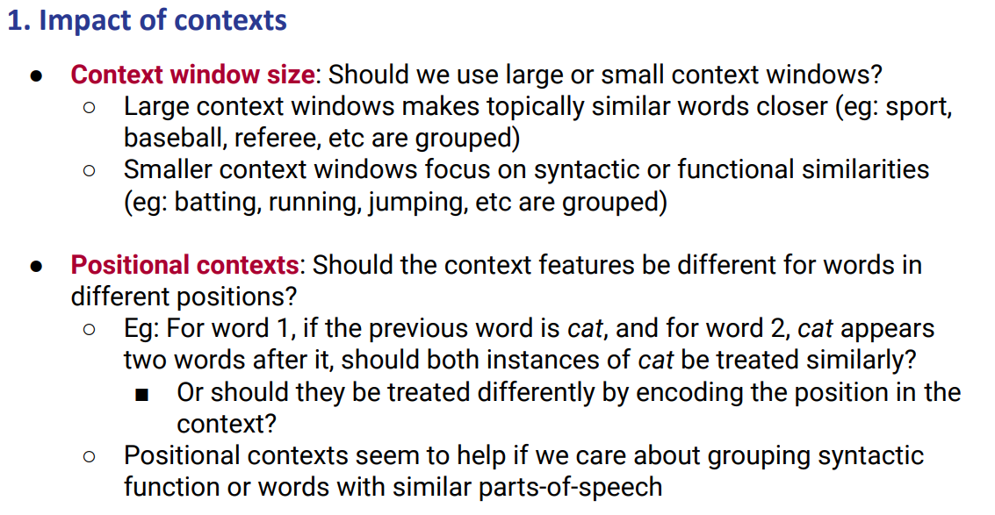
We find out that large content windows make topically similar words closer, while smaller context windows focus more on syntactic or functional similarity.

There are positional contexts: should the contexts feature be different for words in different positions? Maybe we have a word that appears two times in different positions inside a sentence. Should we train this as two different words or as the same? We need to decide before

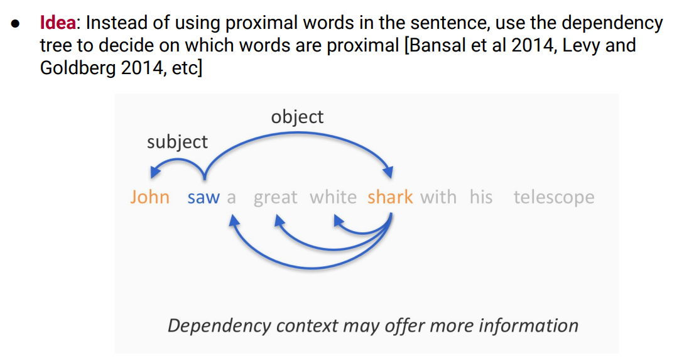

If we use a context window of 1. We have for saw the subject john and a. But with the syntactic context is better because shark will be a better context than a for the word saw.

All the choices will have an impact in the model
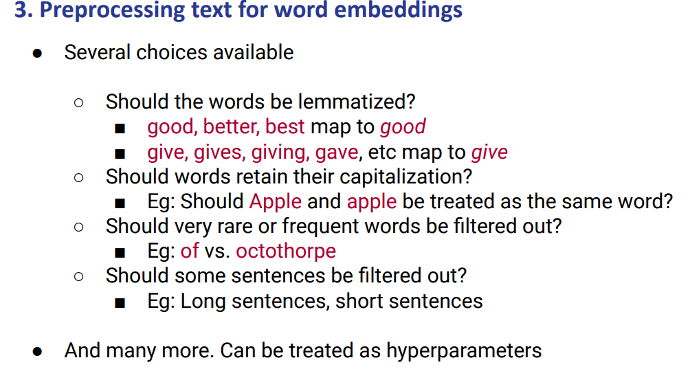
Should we process the words before?

Should the words be lemmatized?
Should good,better, best map to good? we reduce the complex size but we will use some information (good ≠ better)

Show the words maintaining their own capitalization (like Apple vs apple)

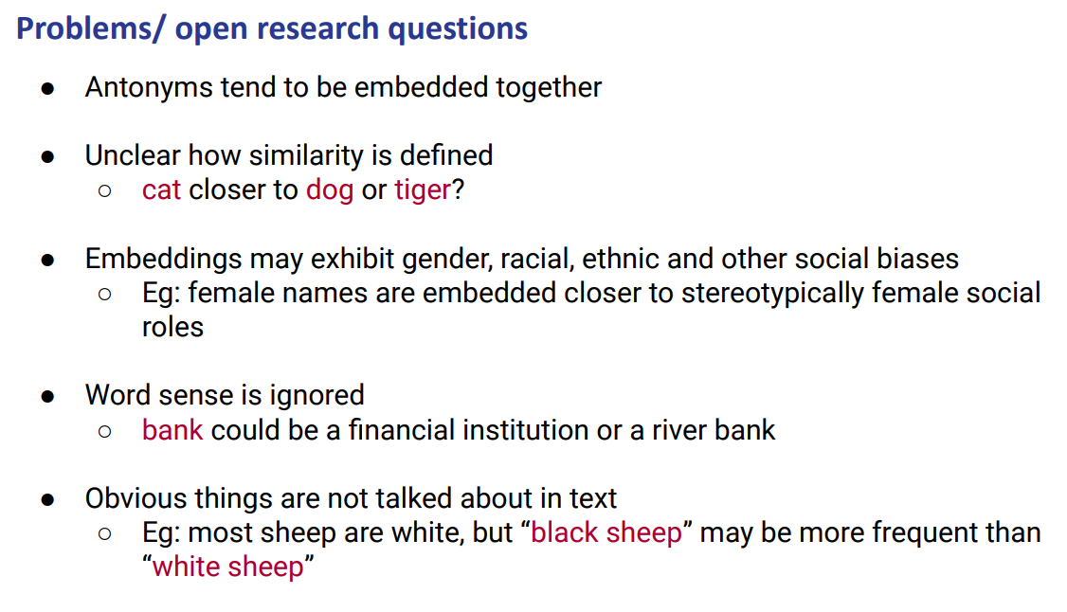

It is unclear how similarity is defined

We need to find another way to express the knowledge or we need to know that some objects are not representation

Also usually a sheep is white we don’t write white it will not be close to sheep. While black might be closer.

Contextualized word embeddings

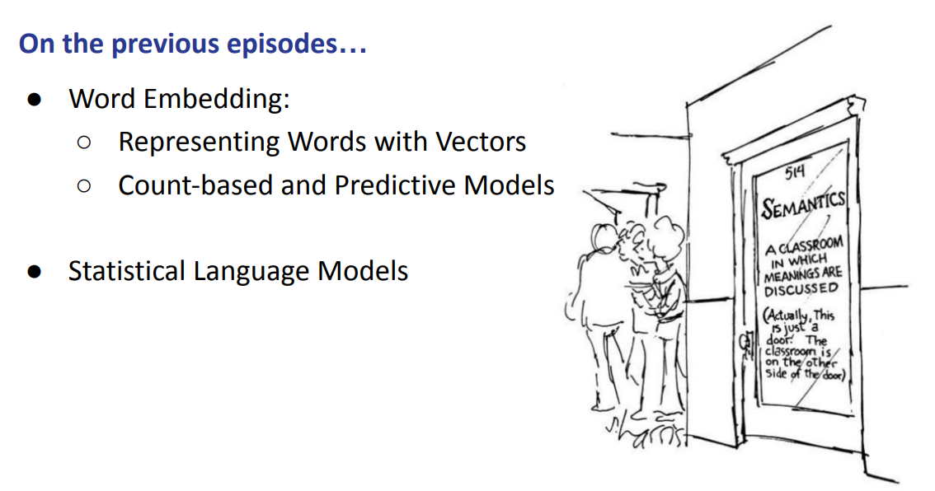
So far:

Word embedding as representing words as vectors and count based and predictive model (like word2vect) and we saw statistical language models (ngram)

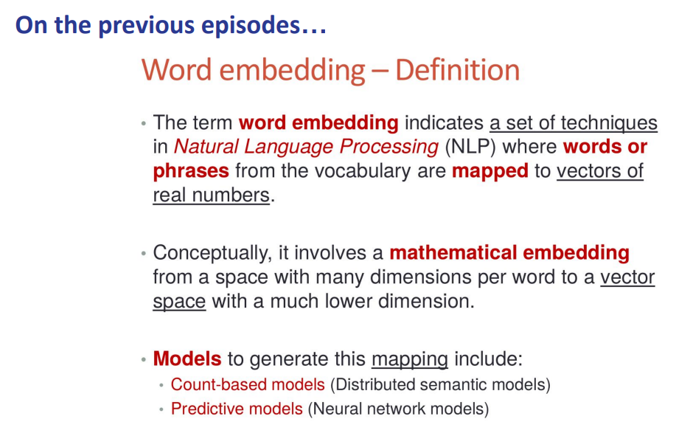
Words are mapped to vector of real numbers

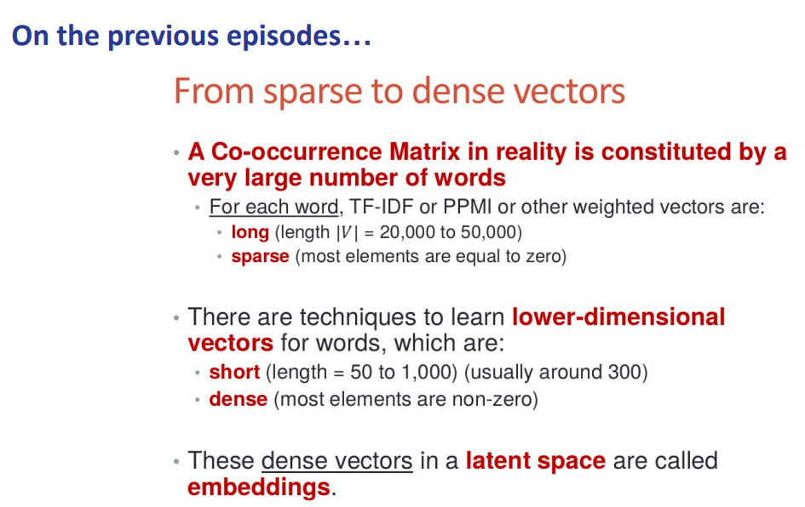
We moved from sparse to dense. We started to build some to avoid very sparse and long matrix, we build something that is short and dense

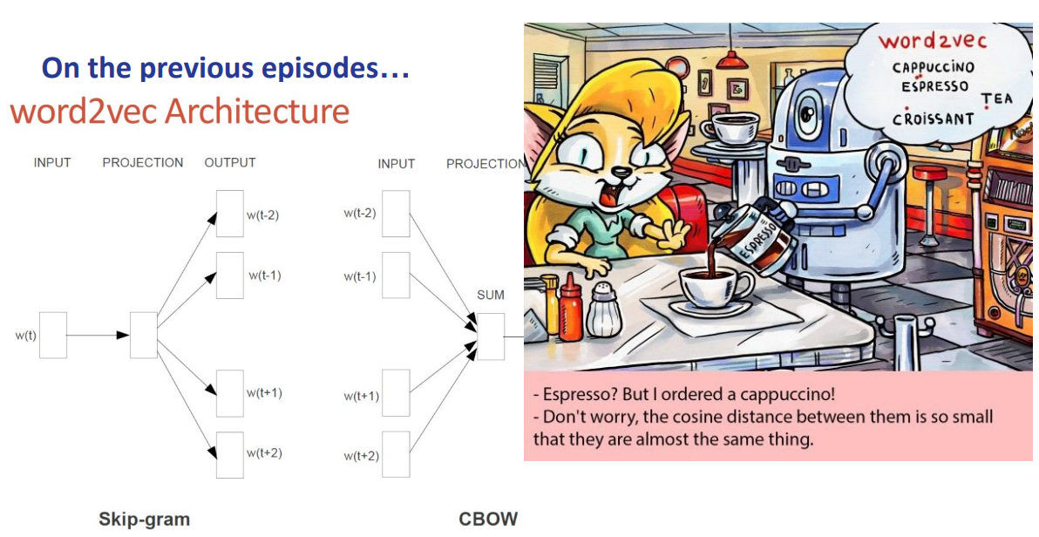

Some architecture (like word2vect) with two alternatives (skipgram and cbow).

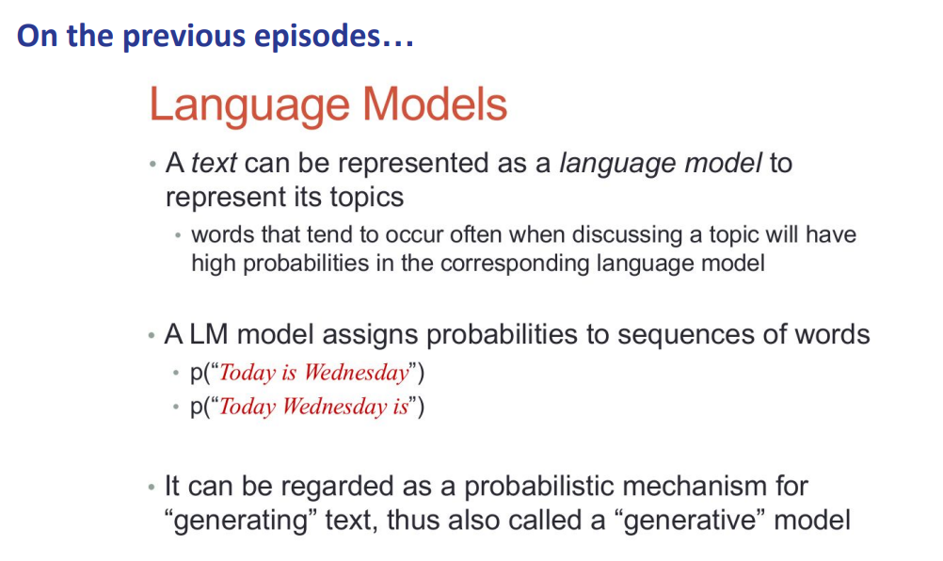

A text can be represented as a language model to represents its topic and the language model assign probability to sequences of words and it can be seen as a probabilistic mechanism for generating text (it is a generative model)

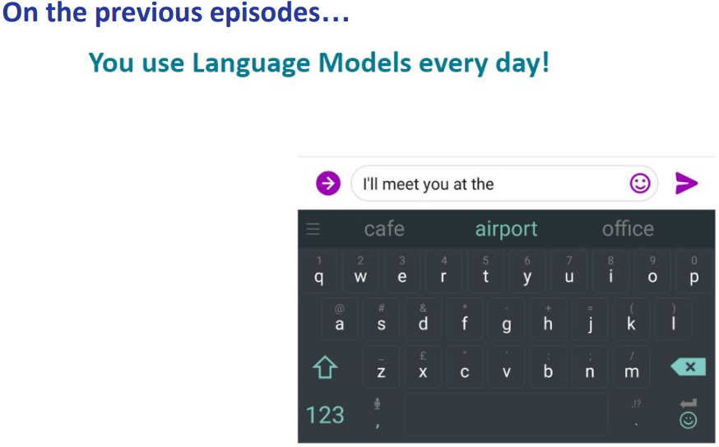
you use a language model everyday. The keyboard uses a language model

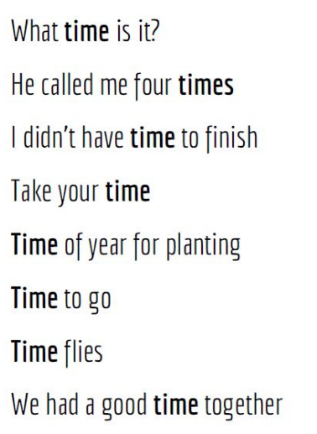

You have a list of sentences. with focus on the word time. It has different meanings and it is in different positions, sometimes different meanings but related to others.

We have relay different or slightly different sometimes. Sometimes they refers to the same meaning

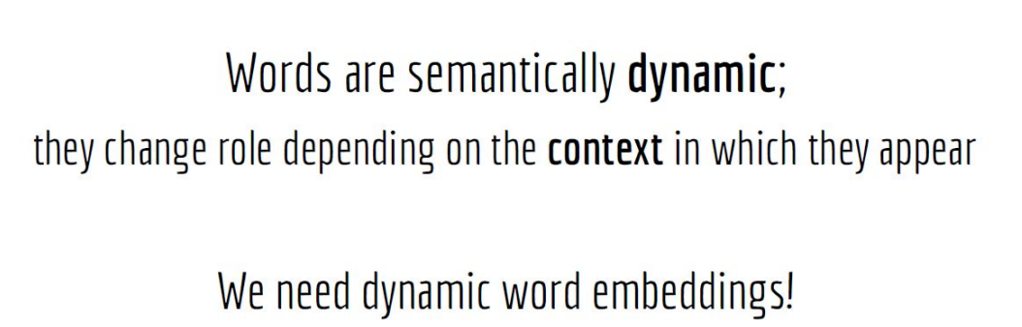

Words are semantically dynamic; they change the role depending on the context in which they appear. We try to code the dynamic nature of the words, something that (depending on the context) will get different results

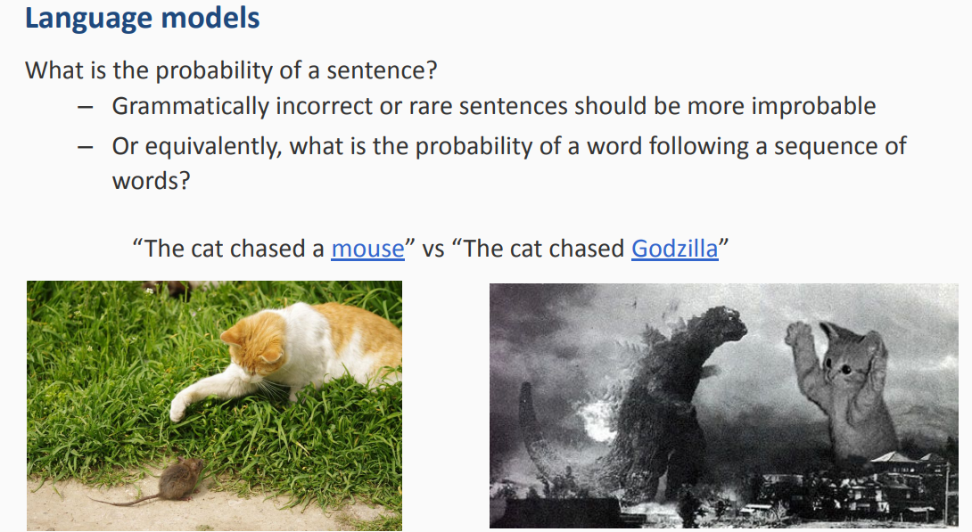

why language model is a way to go? A language model gives us the probability of a sentence or tells us the probability of the next word. You will get different probability
Also it can be different. The language model is implicitly learning something. We saw that we have the problem of meaning (as for the word mouse) that has multiple meaning

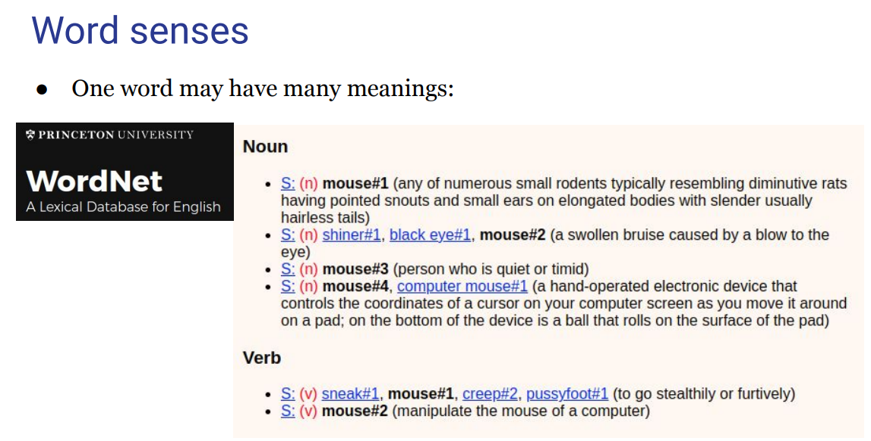
Each word has multiple meanings, not only as a noun but also as a verb. Can have different meaning

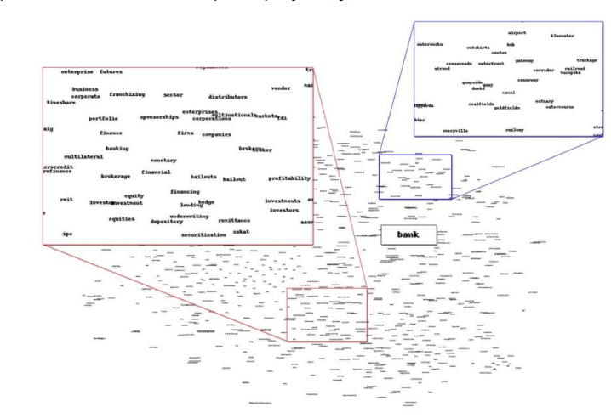
We have the problem of meaning conflation deficiency that we solved before

we want to avoid plant example we try to build something that depending on the context it gives us one representation or another

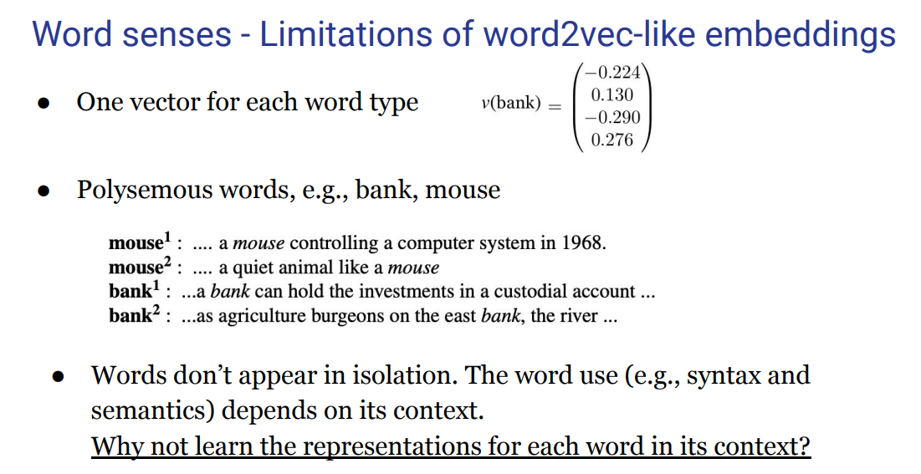
The limitation of word2vect is related to the one of the senses. We have one vector for word. We have polysemous word and we would like to have a vector for each type of word.

But also words do not appear in isolation.
Idea: why not learn the representation for each word in its context. Instead of a static dictionary we want to have something dynamic in which depending on the sentence we have in input we get their representation as output. Something that change every time we have a different senses.

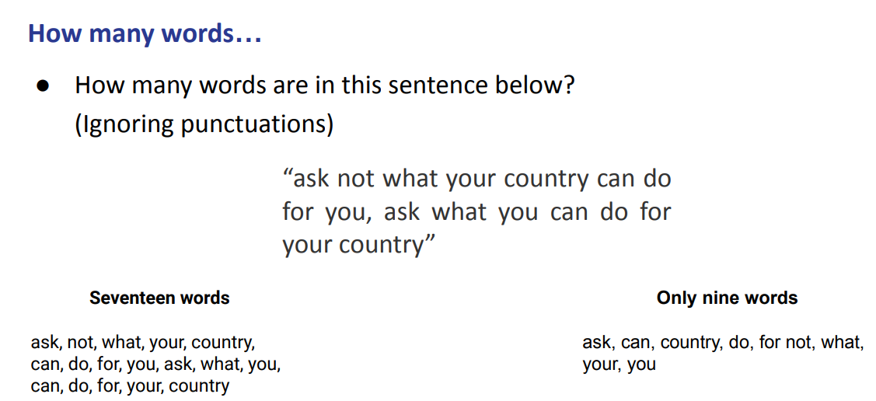

How many words are in this sentence?

There are only 9 words (if you only look for the unique words). Which of these interpretations did we use when we want to count?

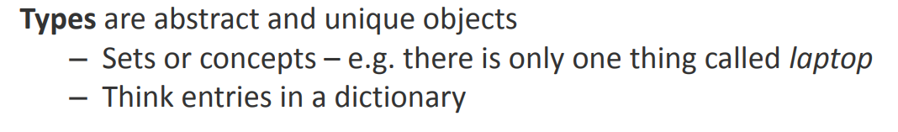
Type words: unique word ⟹ there are 9 word types

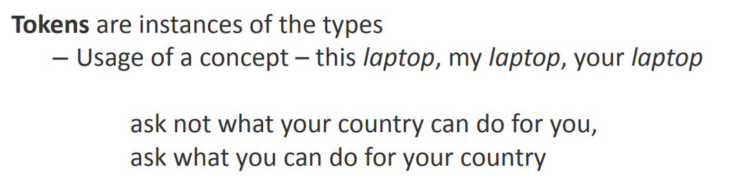
Token words: there are 17 word tokens. It is about the use of a concept

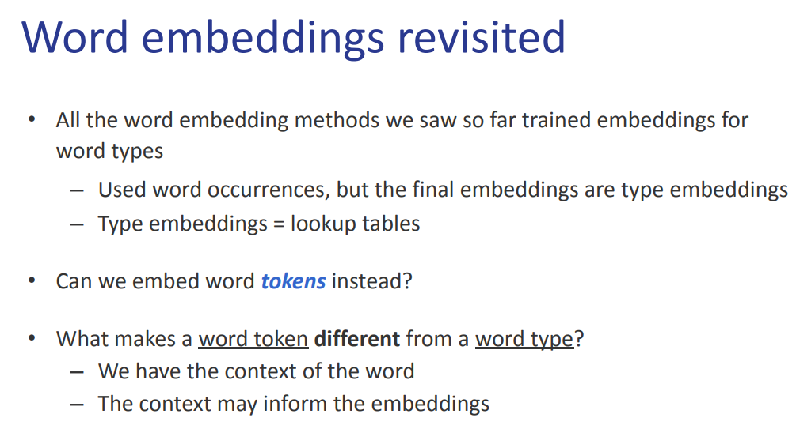
We want to embed word tokens. How can we do this?

Word token is different from a word type simply because of the context. When we learn word type we use the word context.

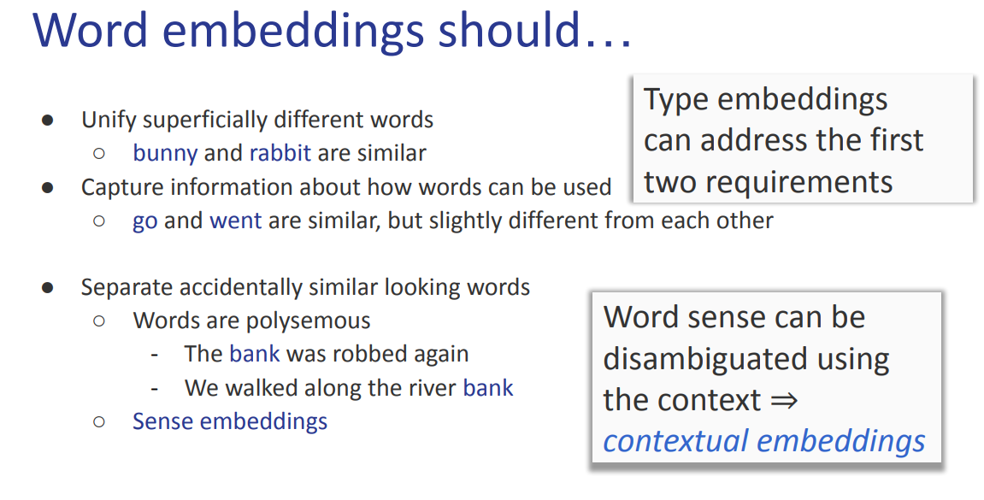
We want some properties for words embedding. It needs to put close words together (like bunny and rabbit) and they should capture information on how words are used.

go and went are similar but slightly different. They need to separate similar looking words.
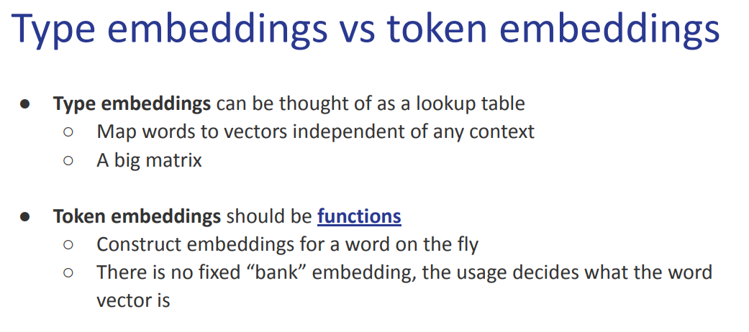

Token embeddings should be functions, a function takes as input a sentence and give us the embedding. If the sentence changes then the function should give as a different embedding (it should be dynamic)

We want a method that constructs this embedding on the fly. Also there should not be a fixed “bank” embedding. Embedding should come alongside with the context. When we use words we do not use them just as a list of words but in some context and we want to incorporate it in some notion to construct embedding

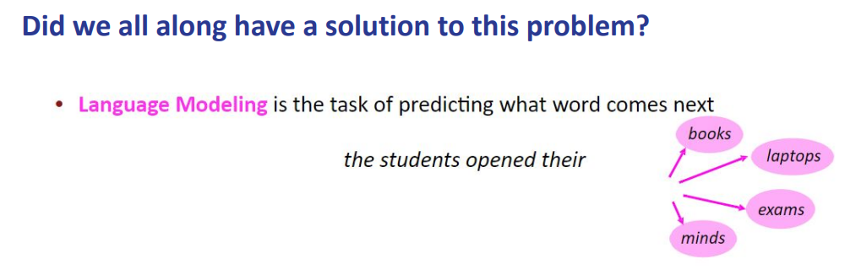
The language model task is to predict which word will come next.

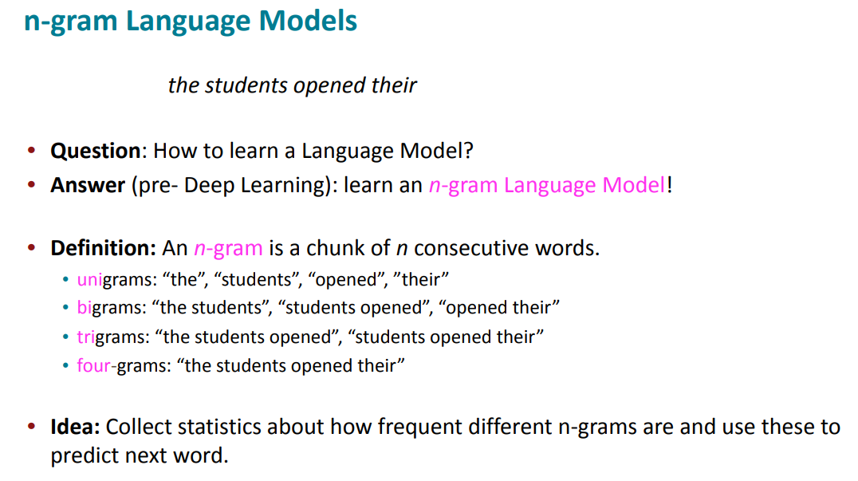

How to learn a language model? we saw how to learn it as an ngram

We saw that the ngram is on the amount of consecutive words and we saw some examples with the bigrams.

Here the idea is that we collect statistics on how frequent the ngrams are and we use it to predict the next word. We build the ngram language model by counting the words to predict what come next

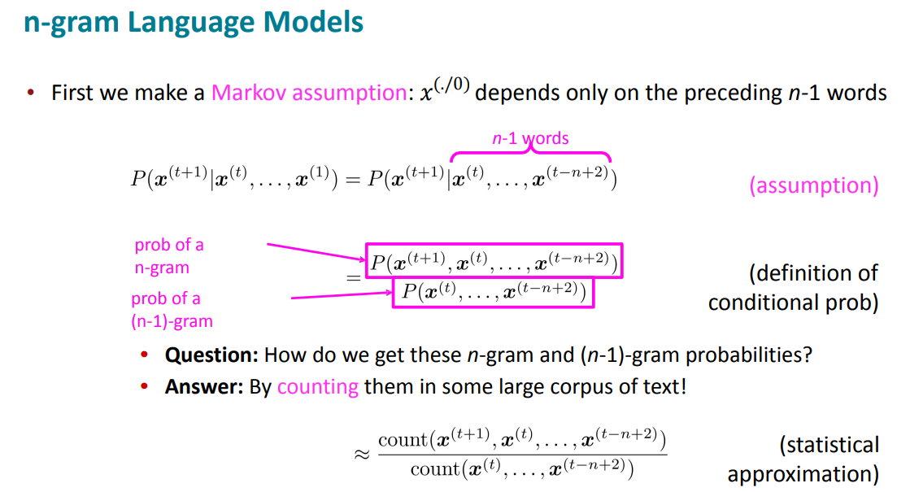
We use the assumption to model probability of words given the history by the count of how many words appear together

we do that by counting large corpus of text

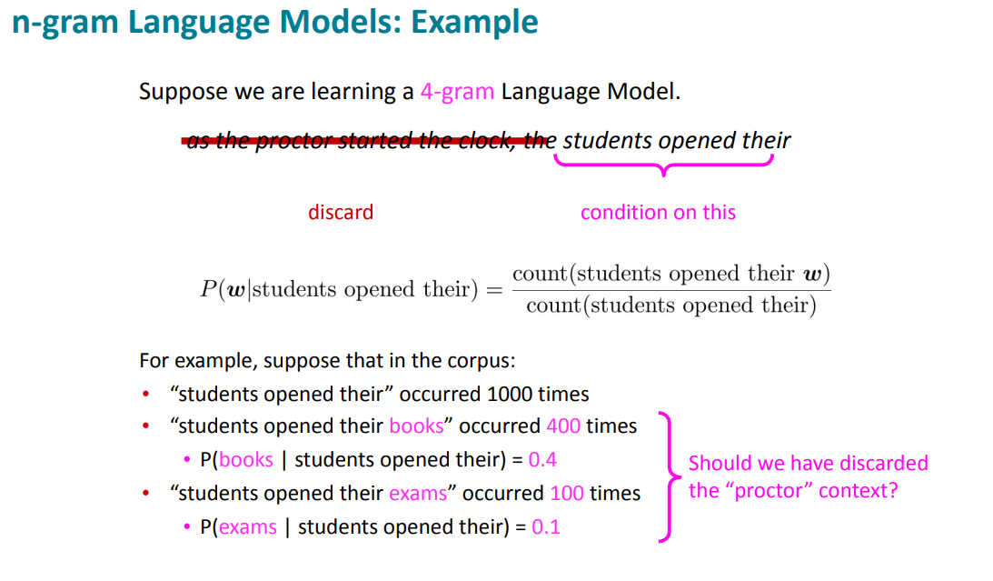
we take the last three words and we model on the last 3 the probability on those

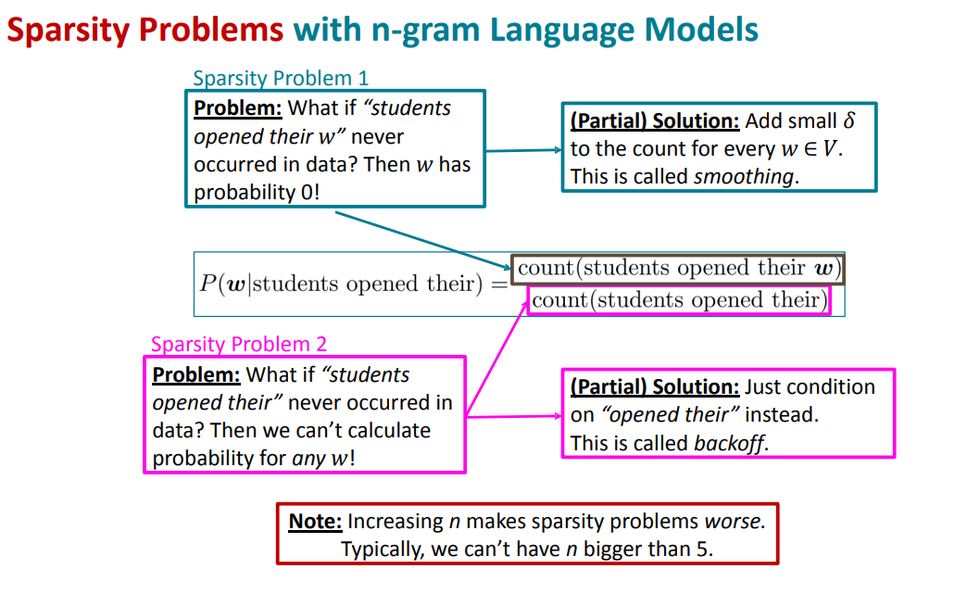
The n-gram language model has some problems, but we saw how to address them.
- We have a sparsity problem
- We have a storage problem
- We have a problem if the word never appeared before in the data. We have two solutions (either smoothing or condition on the previous ngram)

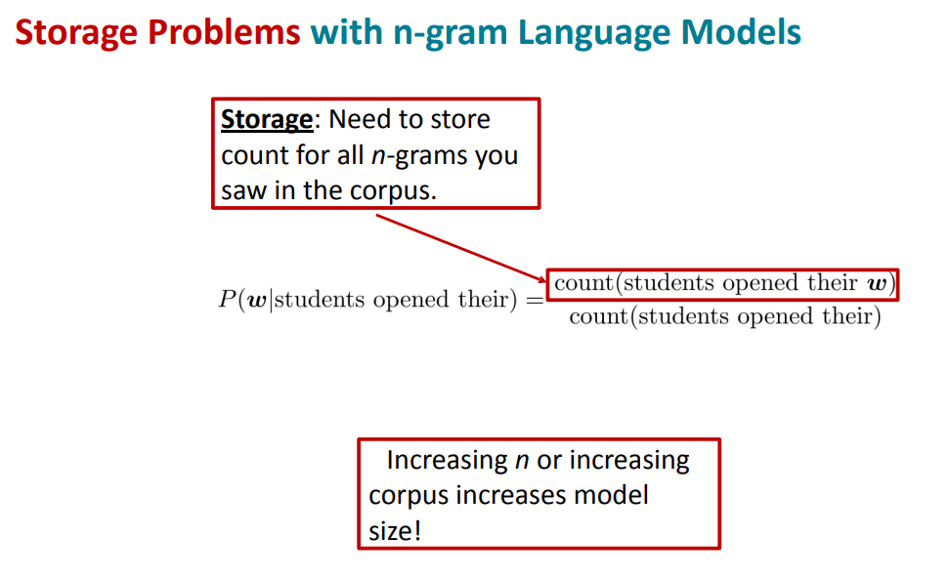
With a bigger corpus you need to store all the ngrams and is bigger and we have a storage problem

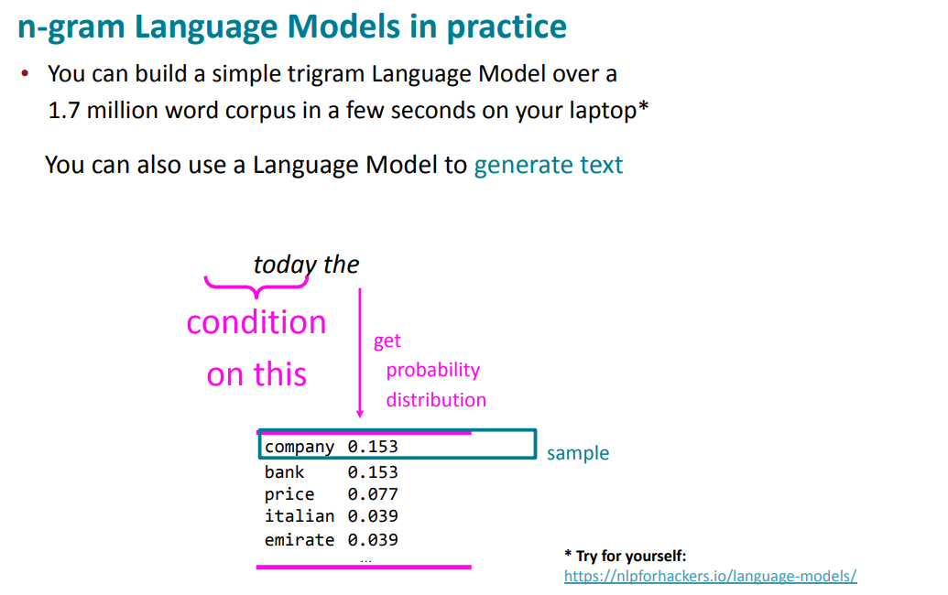
https://nlpforhackers.io/language-models/

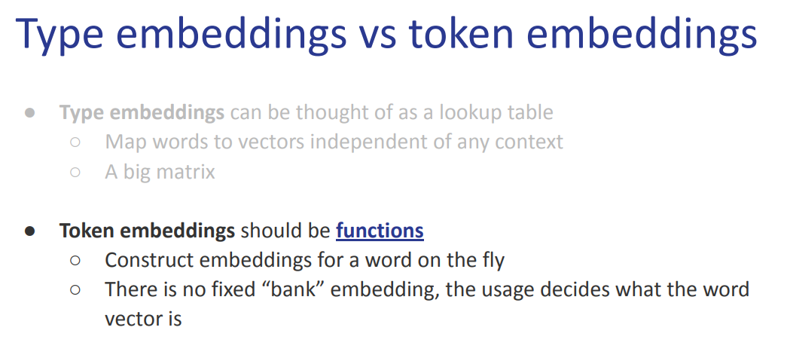
Token embeddings should be functions. We want to construct embedding on the fly.

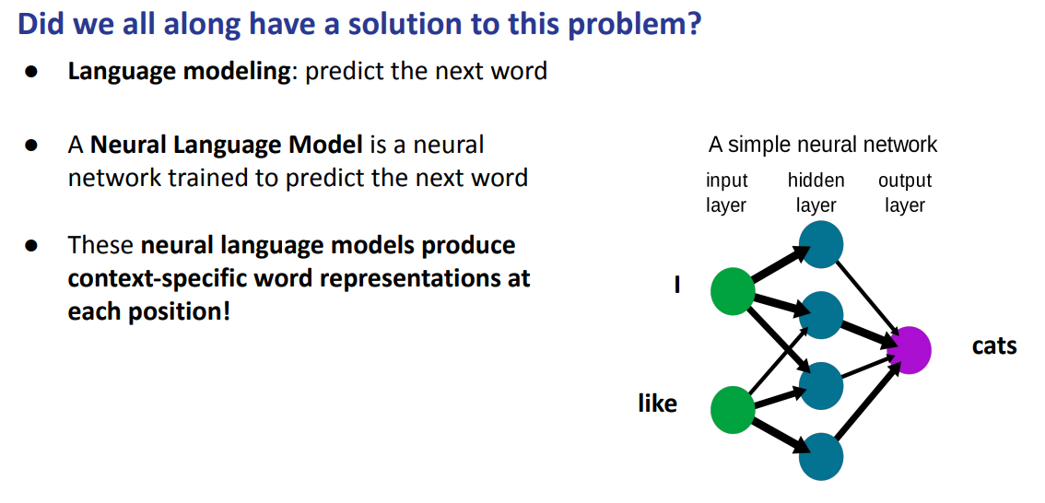
Now we want to learn a neural language model trained to predict the next word. This model produces context specific word representations at each position.

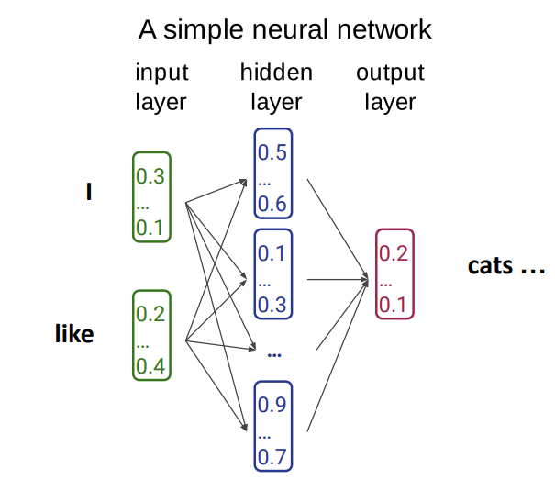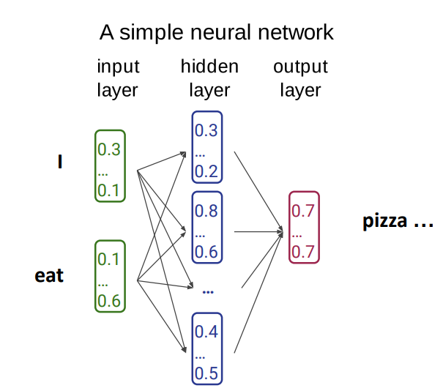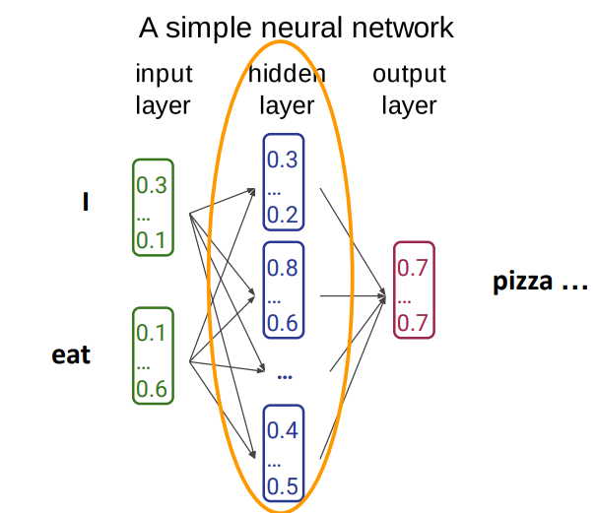

The networks produces an output

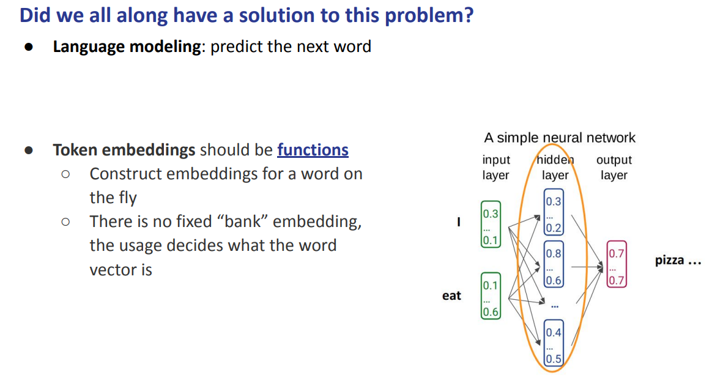
The token embedding should be functions. Everytime you use another word

If the language model is good enough then this representation is good, can be seen as a representation of the output word

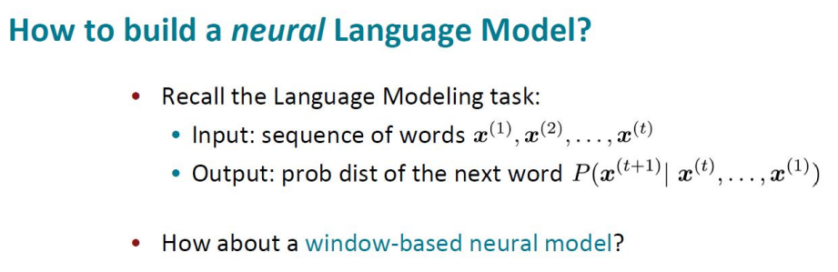
We have a sequence of words as input and as output the probability distribution of the next word. We did it as an ngram by counting.

We can do the same with a neural model. The ngram can be seen as a window

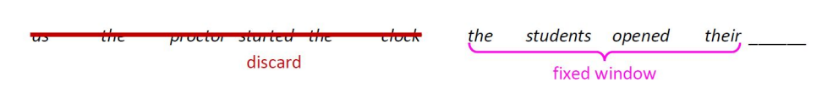
We have a sentence and we decide a fixed window. It is similar to the context in the word2vect style. We decide a window of 4
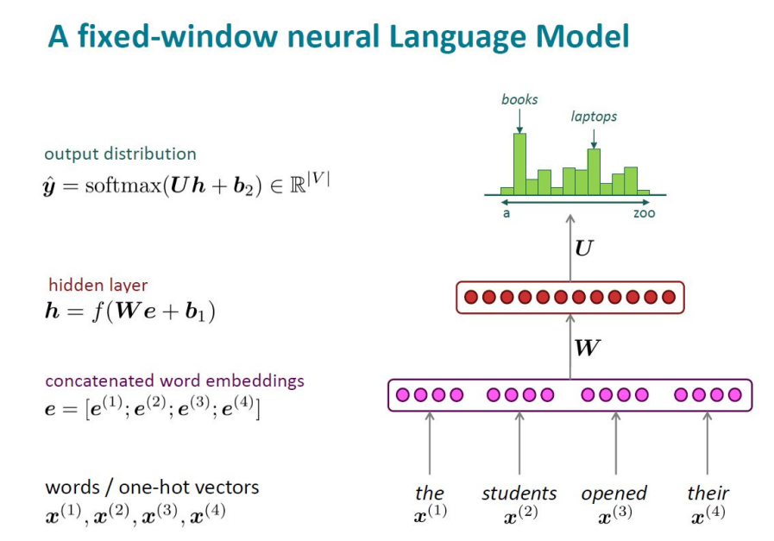

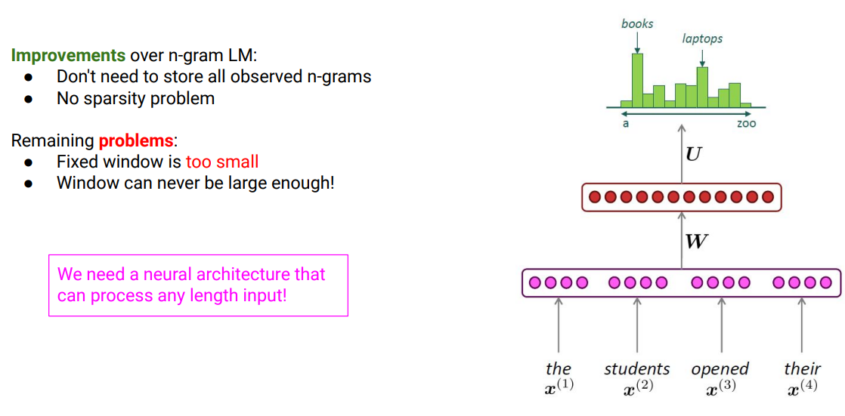
If you train a model like this, you get something better than the ngram but you still have some problems

We have a fixed window and even if you increase a fixed window it is not a solution. We need a neural architecture that can process any length input

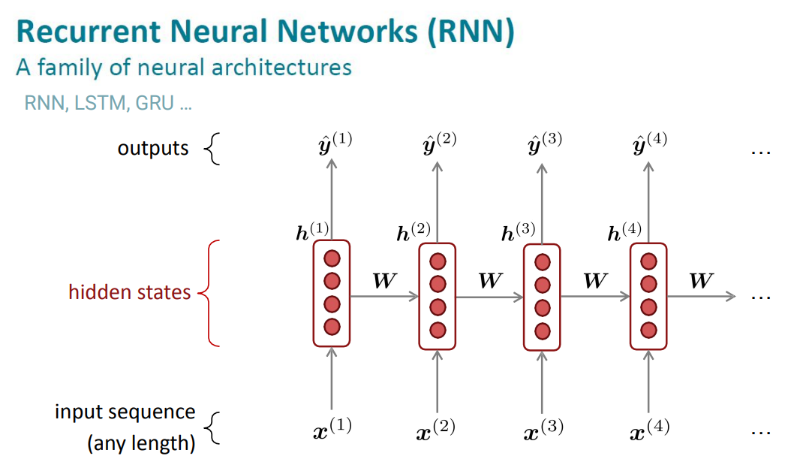
We use recurrent neural networks, were introduced to study images.

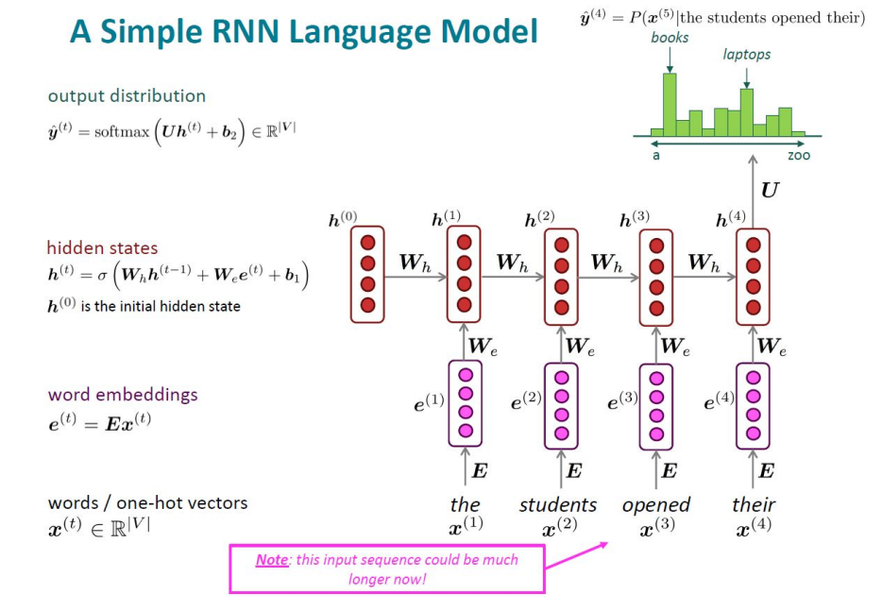

The representation gives us the output and it incorporates the context and the target word. Thanks to the recurrent neural network you can get rid of the fixed side window, and just model our language model up to any length

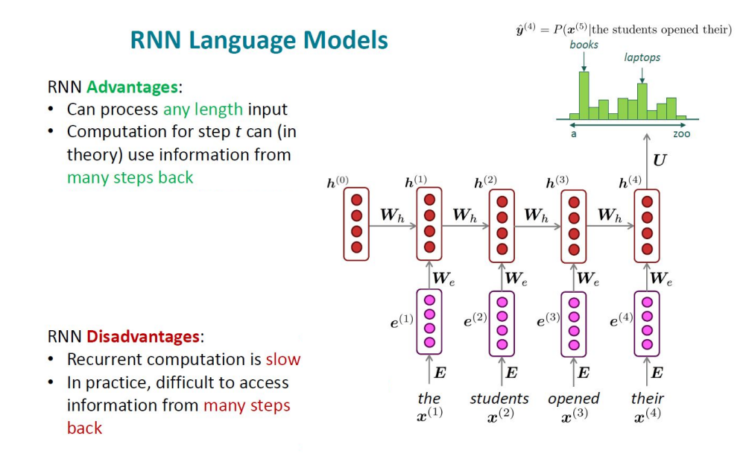

We have some advantages and some disadvantages.

Advantages
- can process any length input and the computation of one step in theory can use information from many steps back

The disadvantages
- the computation is actually slow and takes more time
- It is difficult to access the information from many steps back

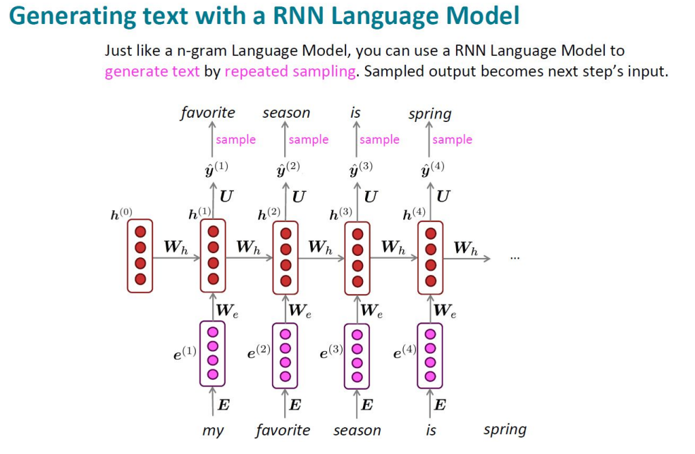

Once we trained something with this you can actually use it to predict text. For each word you just produce the output.

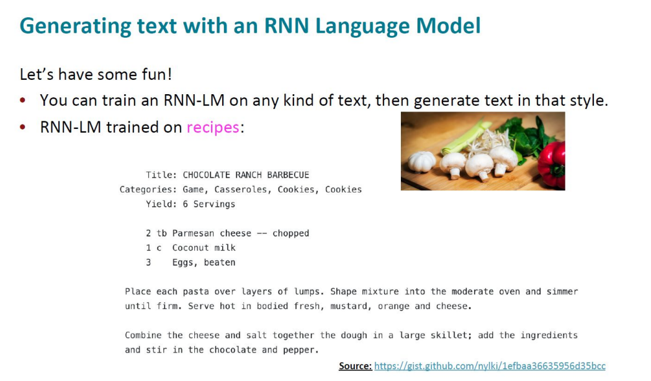
You can train this as done in the previous lecture. And you can try to generate text in that style.

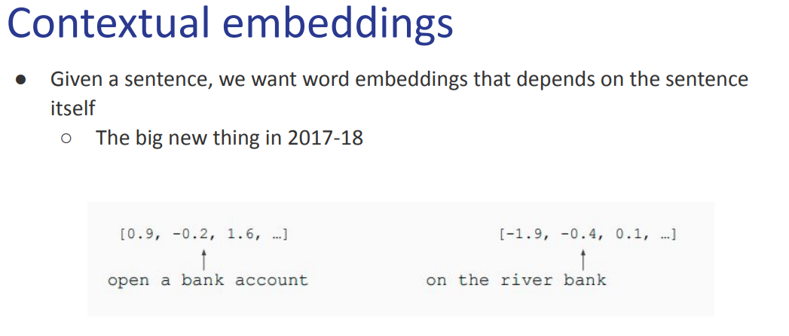
Two popular methods to exploit the task of language model.

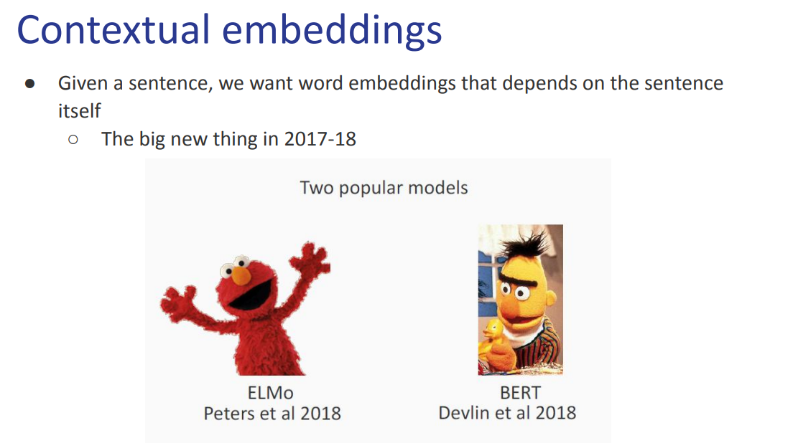
ELMo and BERT
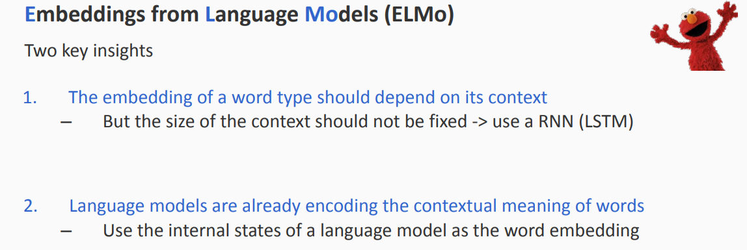
ELMO (Embeddings from Language Models)

The embedding of a word type should depend on its context, and we want to use the recurrent style of the network and the size of the context should not be fixed. If we fix the context we might have a long sentence.

They can actually process a context of any length, and have the full context as window

Also language models are already encoding the contextual meaning of words.
We can use the hidden state as word embedding. The function changes any time.

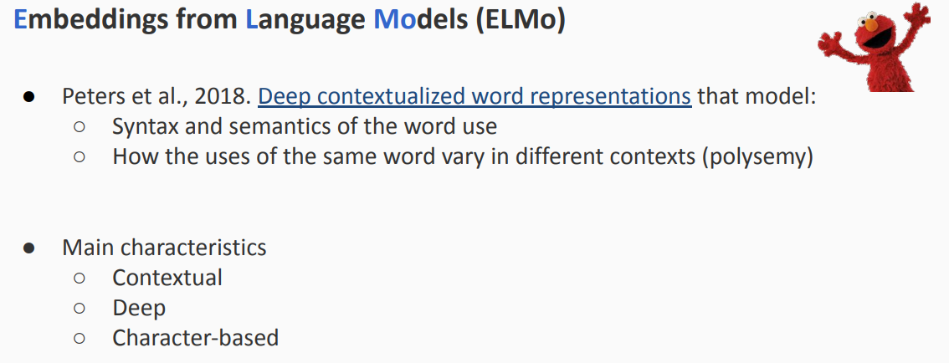
By using the full context you can get something dynamic, and if the model is good even if a word is used in two different sentences you get a function with different context but both words should have the same meaning then if the language model is good you should get similar representations.

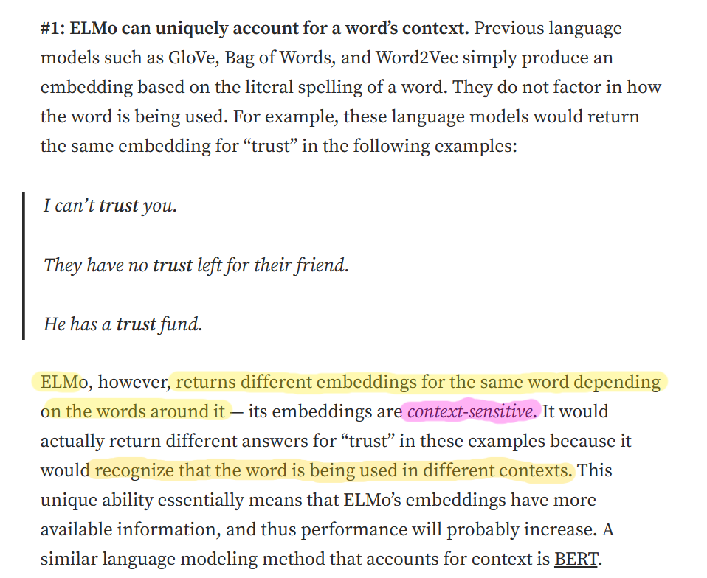

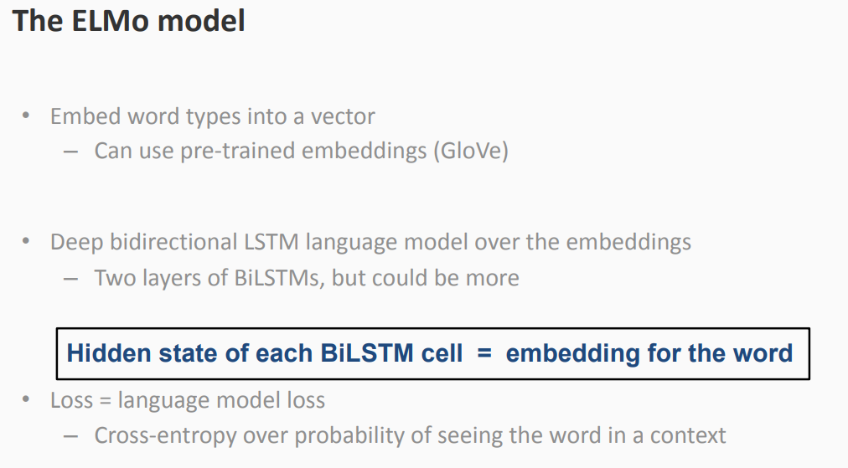
You always have a word embedding layer. Can use a pre trained embedding

You have two layers of recurrent network (could be more). To train, use a loss. For each word you train the model to predict what comes next.

Hidden state of BilSTM (family of recurrent network) will provide the embedding for each word

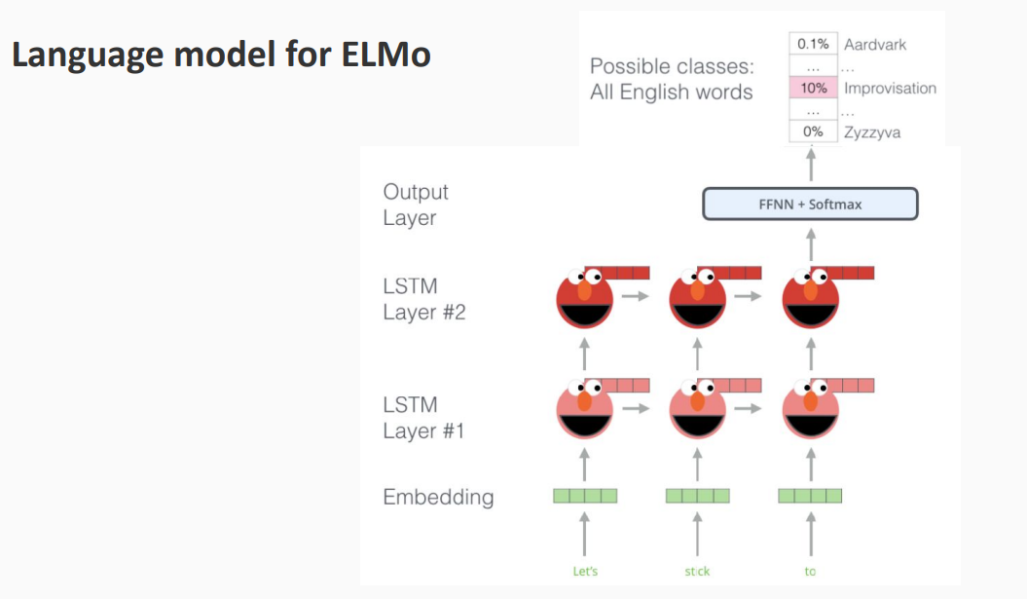
you have your sentence

and world embedding layer

and first recurrent layer and second recurrent layer and get the last representation

we actually have the full sentence, we are missing what comes after. At the beginning you do not have much context

instead of reading from left to right we read both way

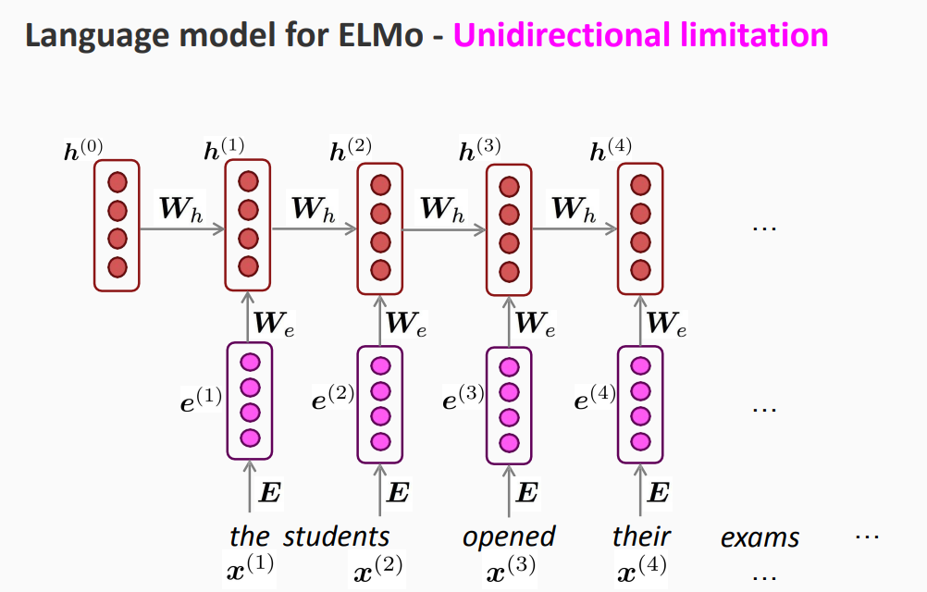

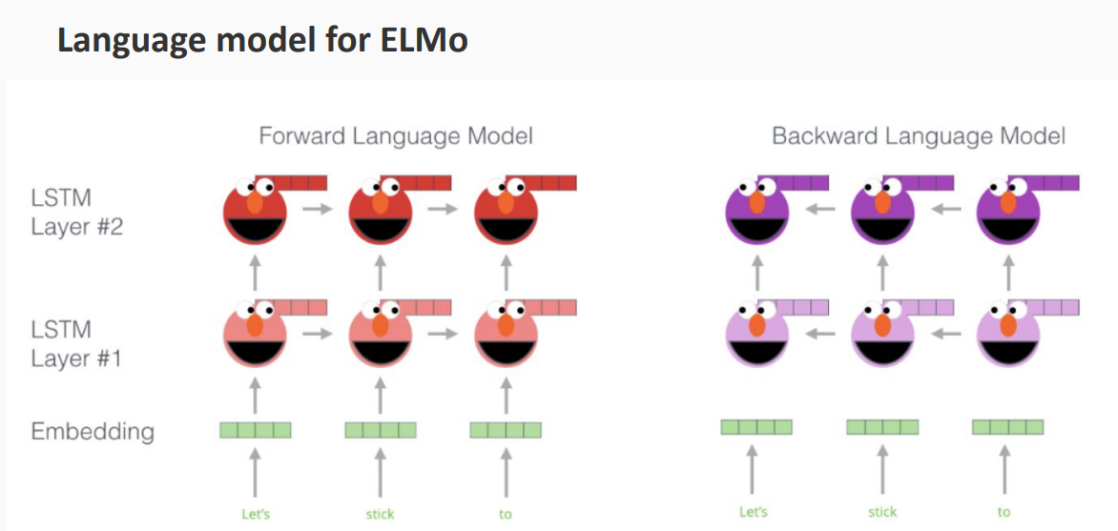

instead of reading from left to right you read from right to left. 2 recurrent models at the same time. Try to overcome the directionality issues

We have two representation, we can choose the representation for each word

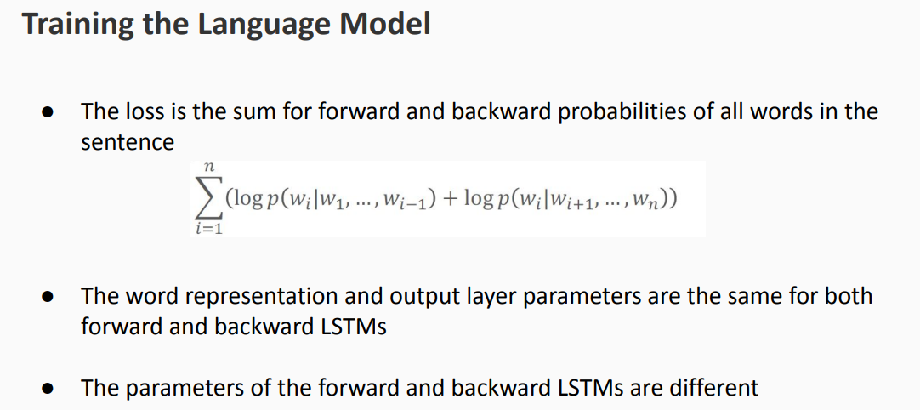
you train the network as sum of forward and backward

basically you train the two networks with the same loss

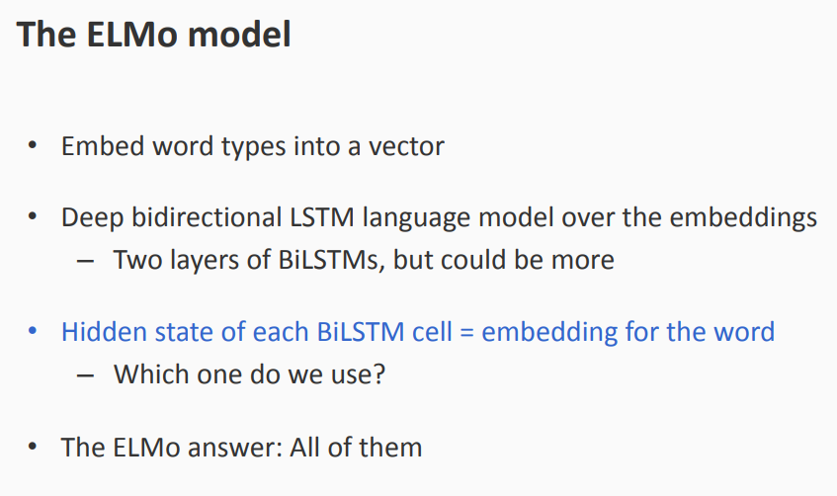
you use both representations. Instead of only the last representation for each word.

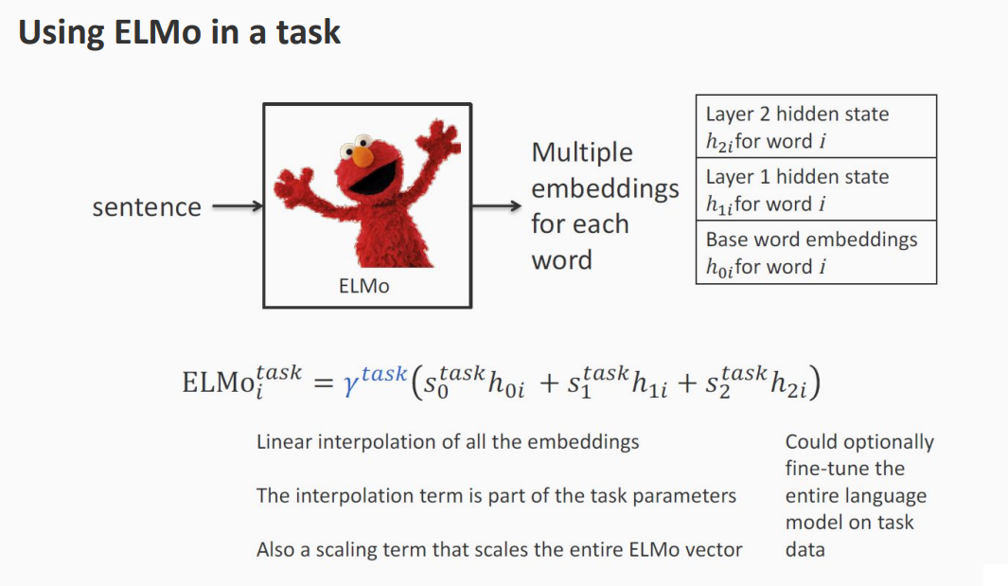
We have a sentence that is given to our model.
Then for each word you have a word embedding. Then you have the two layers (hidden layer 1 and hidden layer 2)

You try to interpolate all the embeddings. If you do the sum you have a better model

Once you train the model you get a representation that you can use for a particular task

We first train the language model (in the example ELMo) and then we use the representation in order to build our classifier than predicts parts of speech
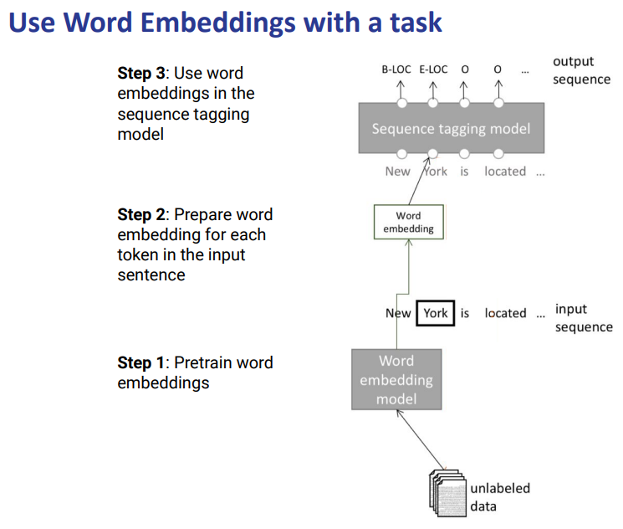
For each word you need to predict whether a location or another word. We want a model that predict for each word a tag (can be anything)

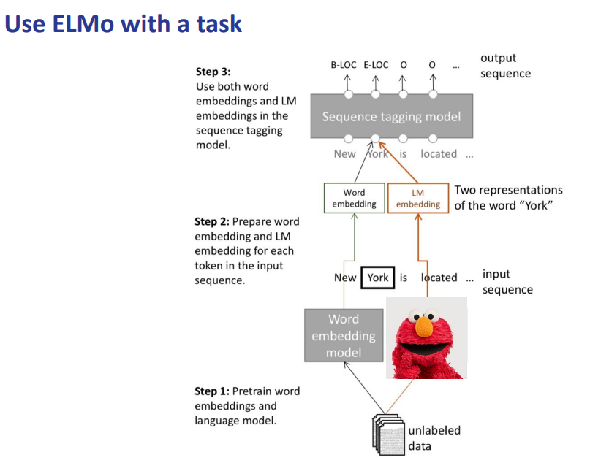
We can use also the representation given by a language model and we train as a language model a task and for each we take the representation of word embedding and then concatenate the representation given by the ELMo embedding and given the representation we train our model that do our task

Building the classier in this way improves the classifier for whatever task we have in mind. This is very useful and get better result for our task
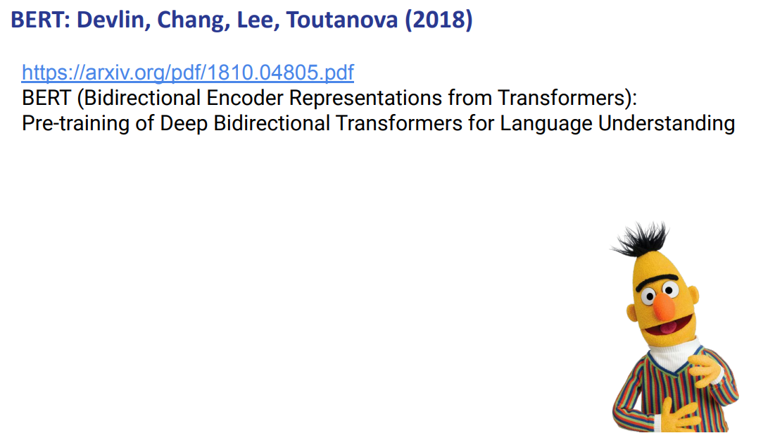

BERT
We have another way to do language modeling (BERT)

Another way is to reconstruct a sentence. Not just focus on the next word.

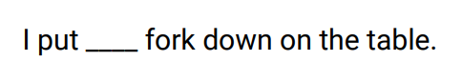
We are just looking at the total sentence, not just the left part. You are still able to predict what comes for the ___

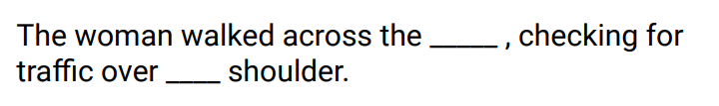
You are still able to fill the gaps

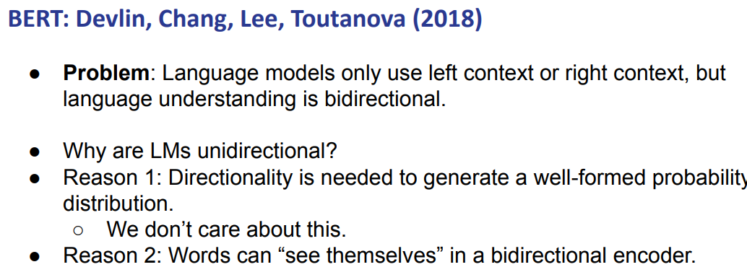
The idea is that maybe we can remove some words and then we let the model fill the gap.

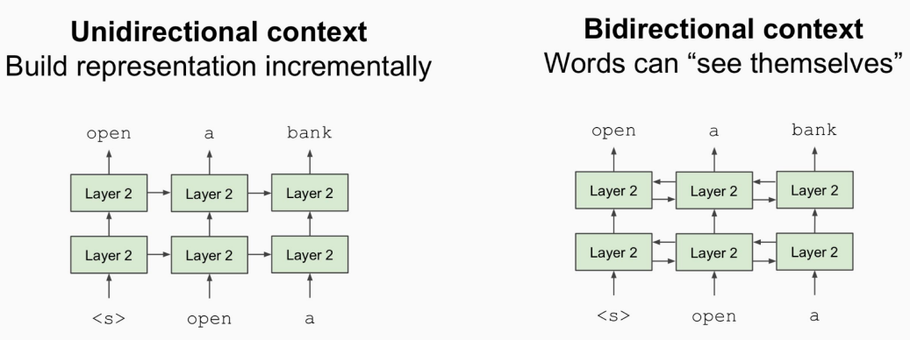
we want something bidirectional when words can see themself

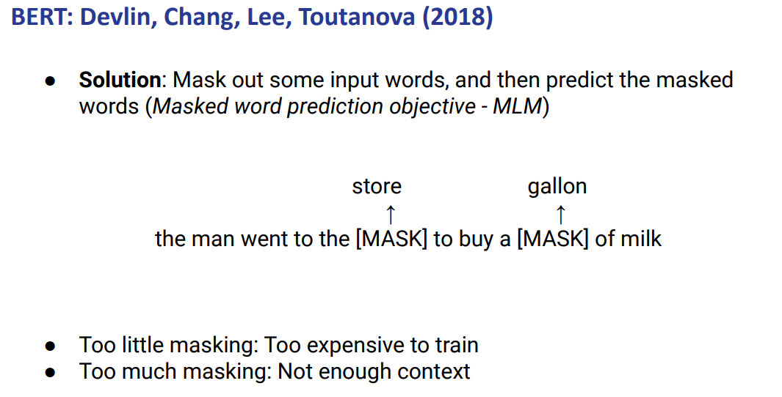
The idea is that we have a sentence and we mask some words and we let the model try to find out what those words should be

It is a compromise: we need to understand when there is too much masking or not and there is not enough context to predict how to fill the gaps.

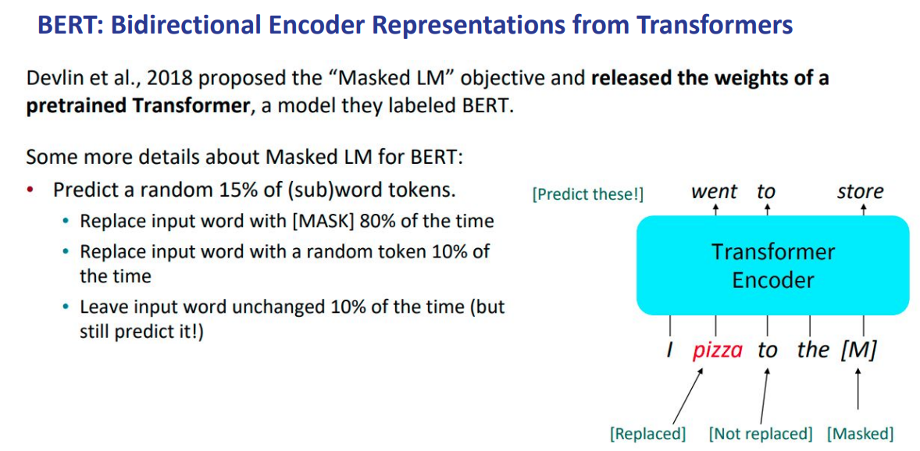
we should mask around 15% of words

but the 15% is splitted in 3 types of masking
- 80% of the 15% replace the input with [mask]
- 10% we put a random token instead of mask
- 10% you leave it unchanged. Let predict to the model the input itself

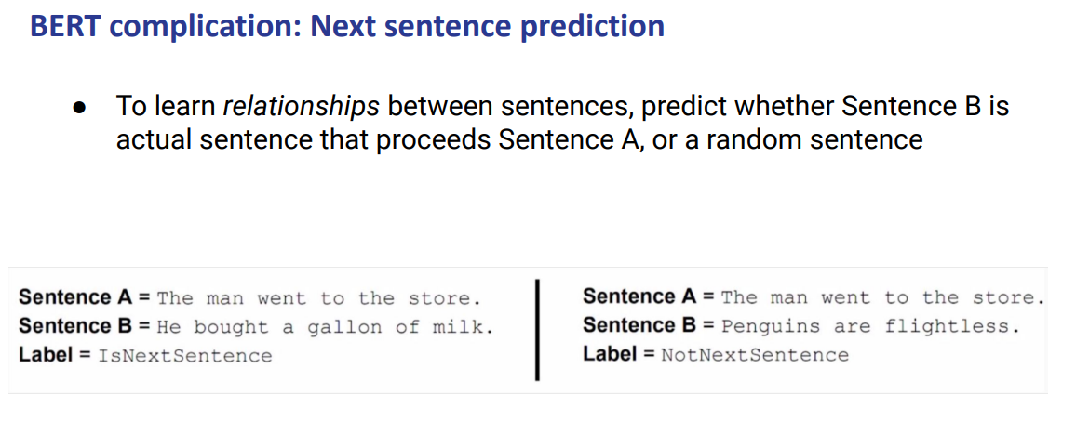
try also to incorporate relationship between sentences

you have as input two sentences and you have to not only fill the gap but also to predict the label to say if the sentence B is actually a probable next sentence of A

To do this you need to have a corpus where you do not only have the information sentences but also the information documents. You need to know if a sentence is actually the next one or not

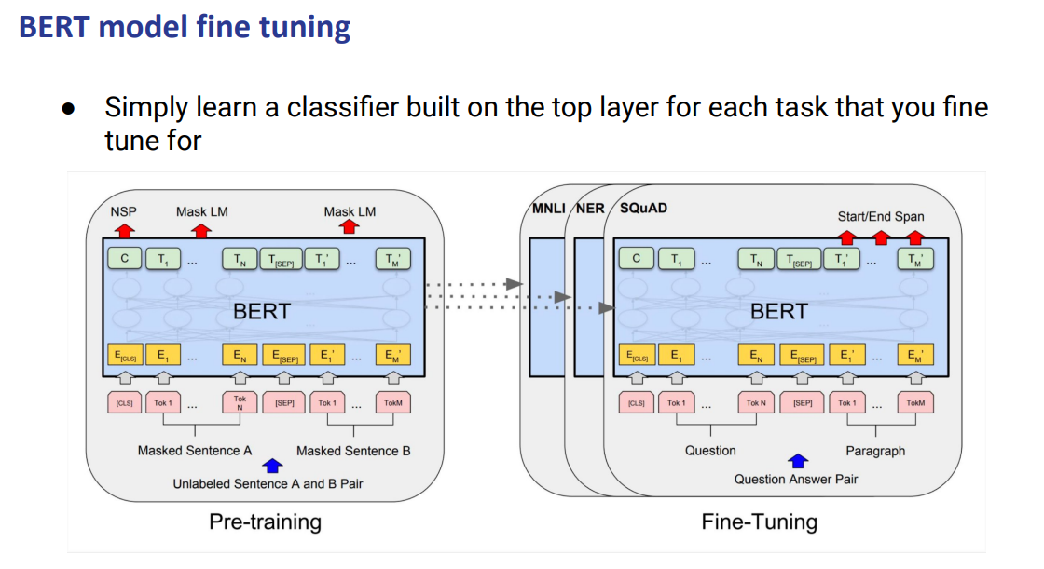

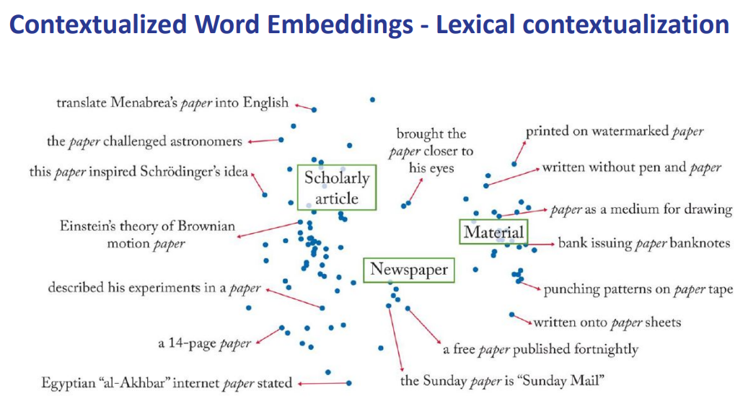
we mode to word token embedding. the live in sentences, each word have a different embedding every time that appears in different sentences

Now we can visualize something like this where each word has an embedding given a full context. You can plot words that are in their own sentence

